

**St Albans City & District**

**Community-wide Emissions Summary 2024**

**Introduction to Community-Wide Emissions Data**

Data Source: The Department for Energy Security and Net Zero (DESNZ) release area-wide emission statistics broken down by local authority area each year. The latest report[1] was released in June 2024. This summary is based upon Table 2.1: Local Authority territorial carbon dioxide (CO2) emissions estimates within the scope of influence of Local Authorities 2005-2022 (kt CO2e). This dataset excludes large industrial sites, diesel railways, motorways, land-use, livestock and soils.

Timescales: Due to the complexity of the data gathering exercise, there is a time lag of 18 months before the data is circulated. The most recent report shows emissions in the District up to 2022. Data is provided on a calendar year basis.

Greenhouse Gases: From 2005-2020 the data covered only carbon-dioxide. There are data sets now for methane (CH4) and nitrous oxide (N2O) but these gases aren’t included to the Local Authority statistics used in this report.

DESNZ data is available for hydrofluorocarbons, perfluorocarbons, sulphur hexafluoride and nitrogen trifluoride (collectively referred to as fluorinated gases or F gases), but they are unable to allocate these at a local authority level. While F gases make up only 2% of overall UK emissions, their exceptional warming potential means that their global warming potential is up to 26,000 times that of CO2. Abatement technologies at production plants have cut F-gas leakage by over 99%. The largest source of emissions is now the refrigeration, air-conditioning, and heat pump sector, where emissions are released due to refrigerant leakage from appliances during use and when they are disposed.

Updates: Each year the datasets are revised to account for methodological improvements and so this year’s dataset supersedes and replaces all previous reports.

A summary of the data is provided in Appendix 1.

**Headlines**

* St Albans District total CO2 emissions for 2022: 494,500 tonnes of tCO2.
* St Albans’ CO2 emissions for 2022 are 7% lower than 2021. This is consistent with national reductions (-5%) in 2022 largely due to reductions in fuel use to heat buildings due to warmer temperatures and higher energy prices.
* District emissions are 43% lower than in 2005 (earliest data available). This is mostly due to decarbonisation of the National Grid.
* Per capita emissions have declined from 6.6 tCO2 in 2005 to 3.3 tCO2 in 2022. This is slightly lower than the England (3.6 tCO2). Population density and rail commuting put us more in line with London per capita emissions (3.2 tCO2). Currently the lowest per capita emissions are in Hackney with 2.2 tCO2 per person.
* By geographical area, the District has reduced emissions from 5.4 tCO2km in 2025 to 3.1 tCO2km in 2022. This is a bit higher than the South East (2.1 tCO2km) or East of England average (1.8 tCO2km) reflecting population density in the area.
* A very slight increase in transport emissions is observed as road traffic increased following the removal of pandemic restrictions.
* 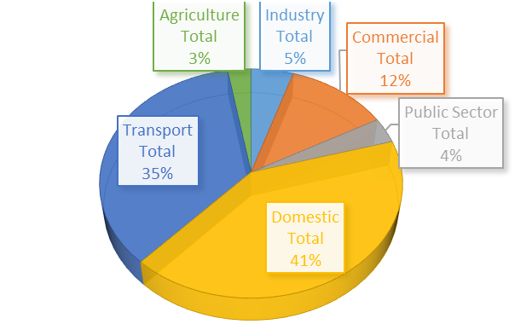These emissions estimates do not include motorways, air travel, consumption of foods and products, nor fluorinated gases. The District’s footprint will therefore, in reality be significantly higher.
* Domestic energy emissions continue to be the largest contributor to the emissions. They are also the easiest to measure.

**Our Targets**

In 2019, SADC declared a climate emergency and set a target to eliminate community-wide greenhouse gas emissions by 2030. In our [Sustainability and Climate Strategy (2020-2023)](https://www.stalbans.gov.uk/sites/default/files/attachments/FINAL%20SADC%20Sustainability%20and%20Climate%20Crisis%20Strategy.pdf), we established a broad target for the community to reduce emissions by 47,000 tonnes each year from 2018. To ensure we were on track this would mean achieving a

* 56% reduction in emissions by 2023 (compared to 2008)
* 64% reduction in emissions by 2025 (compared to 2008)
* 84% reduction in emissions by 2028 (compared to 2008)

By 2022 we were aiming for a **reduction of at least 52%** **from the baseline year,** this meant emitting no more than 405,000 tCO2e. Actual emissions were measured to be 494,500 tCO2e (43% reduction). This is despite the pandemic-related restrictions reducing travel and economic activity in 2020 and 2021.

Each year that our decarbonisation targets aren’t met, more dramatic reductions are needed later. The target reduction has been increased each year and needs to be increased once again. Emissions will now need to be reduced by 61,750 tCO2e each year between 2023 and 2030 if the District is to decarbonise from fossil fuels by 2030.

At the current average rate of reduction, assuming they are achieved consistently, the District would not achieve net zero emissions until 2043. Whilst this is within the UK Climate Change Act target, it does not align with the goals of the Paris Agreement to restrict emissions to keep temperature rises to well below 2C, and ideally 1.5C, above pre-industrial levels. This is necessary to avoid the worst climate impacts.

**During the production of this report we have for the first time surpassed that +1.5°C threshold.**

**Climate impacts**

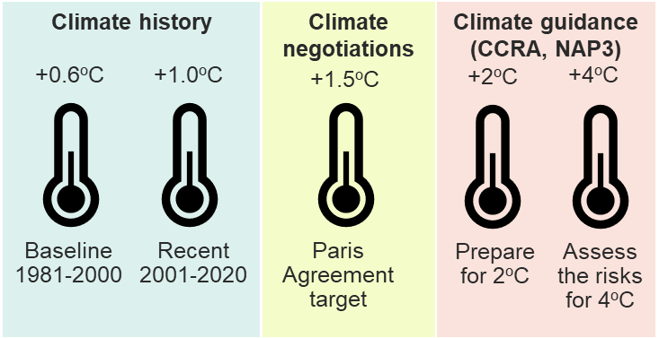

The UK government is, via the Climate Change Risk Assessment (CCRA) and 3rd National Adaptation Plan (NAP3), preparing for a 2C average global rise in global temperature, whilst also assessing the risks for 4C.

The timing of a particular temperature rise depends on future global emissions as well as the sensitivity of the climate system to the changes. The two Global Warming Level projections based on high or central emissions estimates are both consistent with current-policy global emissions reductions.

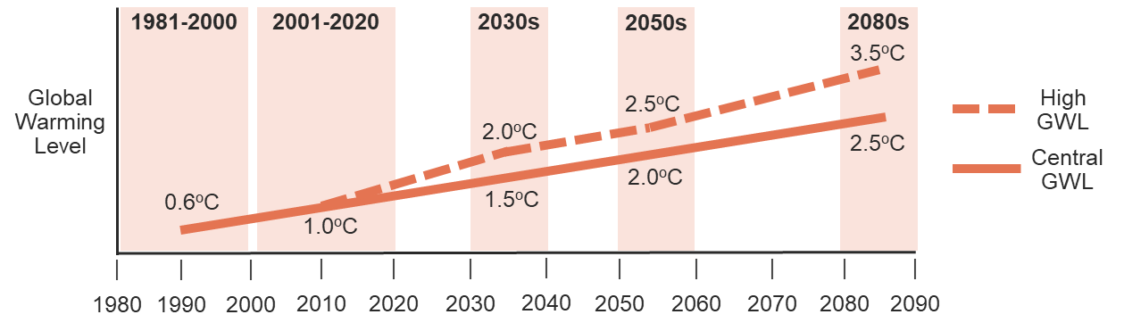

The impact of these temperature rises on [St Albans District](https://www.reports.esriuk.com/view-report/b8eb3cee8f764147a2cfcd69cf36238f/E07000240) are shown below.

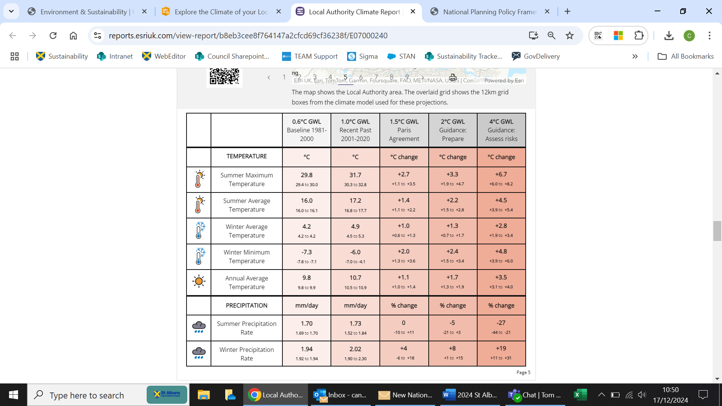

**Recommendations**

To achieve our aims of net zero 2030 or aligning local emissions to the Paris Agreement targets we will need to promote the transition away from fossil fuels across all areas of influence. As a District Council we are limited in our powers to affect local transport or the way residents use energy to power their homes. To be successful we need the backing of ambitious national policy frameworks and are closely monitoring incoming policy to support public transport improvements, home energy efficiency funding and large-scale renewable energy generation.

In 2024, only 26% of UK energy supply was generated from fossil fuels/mostly gas and 16% from electricity imports. This is the lowest level of gas-powered generation since 1996, and the second largest annual reduction outside of the Covid-19 pandemic. Renewable and low carbon energy production made up 54% of the UK energy supply, outstripping fossil fuels for the first time. Our main resource, wind, powered 68% of the country’s electricity in December 2024.

Whilst the grid is decarbonised we can lead the transition by modelling the proactive ‘greening’ of our own assets and services; ensuring local policy encourages and enables sustainable development and behaviour change; and removing the barriers to good practice for example by supporting electric charging infrastructure and improving knowledge levels.

**Appendix 1: St Albans City and District CO2 Emissions 2005-2022 (KTCO2)**



|  |  |  |  |  |  |  |  |  |  |  |  |  |  |  |  |  |  |  |  |  |  |  |  |  |  |  |  |  |  |  |  |  |  |  |  |  |  |  |  |  |  |  |
| --- | --- | --- | --- | --- | --- | --- | --- | --- | --- | --- | --- | --- | --- | --- | --- | --- | --- | --- | --- | --- | --- | --- | --- | --- | --- | --- | --- | --- | --- | --- | --- | --- | --- | --- | --- | --- | --- | --- | --- | --- | --- | --- |
|  | Industrial Energy | | | | Commercial Electricity | | | | | Public Sector Energy | | | | | **Waste** | |  | |  | |  | |  | |  | |  | |  | |  | |  | |  | |  | |  | |  | |
| **Calendar Year** | Electricity | Gas | Other | **Total** | Electricity | Gas | Other | **Total** | Electricity | | Gas | Other | **Total** | **Total** | |  | |  | |  | |  | |  | |  | |  | |  | |  | |  | |  | |  | |  | |
| 2005 | 16.1 | 12.7 | 8.6 | **37.4** | 112.8 | 24.1 | 5.8 | **142.7** | 20.6 | | 17.9 | 5.0 | **43.4** | **0.2** | |  | |  | |  | |  | |  | |  | |  | |  | |  | |  | |  | |  | |  | |
| 2006 | 17.3 | 11.9 | 7.6 | **36.8** | 121.6 | 22.6 | 5.8 | **150.0** | 22.2 | | 16.7 | 4.1 | **43.1** | **0.2** | |  | |  | |  | |  | |  | |  | |  | |  | |  | |  | |  | |  | |  | |
| 2007 | 17.2 | 10.9 | 7.6 | **35.7** | 121.0 | 20.8 | 5.3 | **147.1** | 22.1 | | 15.4 | 4.0 | **41.5** | **0.2** | |  | |  | |  | |  | |  | |  | |  | |  | |  | |  | |  | |  | |  | |
| 2008 | 16.8 | 10.8 | 6.3 | **34.0** | 118.2 | 20.6 | 5.4 | **144.2** | 21.6 | | 15.2 | 2.8 | **39.6** | **0.2** | |  | |  | |  | |  | |  | |  | |  | |  | |  | |  | |  | |  | |  | |
| 2009 | 14.5 | 10.3 | 5.6 | **30.3** | 101.9 | 19.5 | 5.4 | **126.7** | 18.6 | | 14.5 | 2.7 | **35.8** | **0.2** | |  | |  | |  | |  | |  | |  | |  | |  | |  | |  | |  | |  | |  | |
| 2010 | 14.4 | 11.4 | 6.5 | **32.3** | 101.3 | 21.7 | 5.6 | **128.6** | 18.5 | | 16.1 | 2.7 | **37.3** | **0.2** | |  | |  | |  | |  | |  | |  | |  | |  | |  | |  | |  | |  | |  | |
| 2011 | 13.3 | 9.2 | 5.6 | **28.1** | 93.1 | 17.5 | 5.1 | **115.8** | 17.0 | | 13.0 | 2.8 | **32.8** | **0.2** | |  | |  | |  | |  | |  | |  | |  | |  | |  | |  | |  | |  | |  | |
| 2012 | 14.4 | 10.0 | 5.0 | **29.4** | 101.4 | 19.0 | 4.7 | **125.1** | 18.5 | | 14.1 | 2.6 | **35.2** | **0.2** | |  | |  | |  | |  | |  | |  | |  | |  | |  | |  | |  | |  | |  | |
| 2013 | 13.4 | 10.6 | 4.7 | **28.6** | 93.8 | 20.1 | 4.7 | **118.7** | 17.1 | | 14.9 | 2.6 | **34.7** | **0.2** | |  | |  | |  | |  | |  | |  | |  | |  | |  | |  | |  | |  | |  | |
| 2014 | 11.2 | 8.7 | 5.6 | **25.5** | 78.5 | 16.6 | 4.7 | **99.8** | 14.3 | | 12.3 | 2.4 | **29.0** | **0.2** | |  | |  | |  | |  | |  | |  | |  | |  | |  | |  | |  | |  | |  | |
| 2015 | 9.2 | 8.9 | 5.9 | **23.9** | 64.3 | 16.9 | 4.9 | **86.1** | 11.7 | | 12.5 | 1.8 | **26.1** | **0.2** | |  | |  | |  | |  | |  | |  | |  | |  | |  | |  | |  | |  | |  | |
| 2016 | 7.4 | 9.9 | 5.5 | **22.8** | 49.3 | 18.2 | 5.6 | **73.1** | 8.9 | | 11.4 | 2.5 | **22.8** | **0.2** | |  | |  | |  | |  | |  | |  | |  | |  | |  | |  | |  | |  | |  | |
| 2017 | 9.5 | 10.4 | 5.8 | **25.7** | 39.5 | 16.4 | 5.5 | **61.4** | 9.8 | | 10.9 | 2.3 | **23.0** | **0.2** | |  | |  | |  | |  | |  | |  | |  | |  | |  | |  | |  | |  | |  | |
| 2018 | 6.3 | 9.5 | 6.3 | **22.0** | 41.0 | 22.1 | 5.8 | **68.9** | 7.1 | | 11.3 | 2.4 | **20.7** | **0.2** | |  | |  | |  | |  | |  | |  | |  | |  | |  | |  | |  | |  | |  | |
| 2019 | 6.6 | 10.3 | 7.8 | **24.7** | 33.9 | 21.8 | 6.0 | **61.7** | 6.1 | | 9.8 | 2.0 | **17.9** | **0.2** | |  | |  | |  | |  | |  | |  | |  | |  | |  | |  | |  | |  | |  | |
| 2020 | 5.3 | 8.8 | 7.7 | **21.8** | 27.1 | 30.3 | 6.3 | **63.7** | 4.9 | | 9.8 | 2.1 | **16.8** | **0.2** | |  | |  | |  | |  | |  | |  | |  | |  | |  | |  | |  | |  | |  | |
| 2021 | 6.1 | 12.6 | 7.5 | **26.2** | 31.0 | 33.4 | 5.6 | **70.0** | 5.6 | | 11.9 | 1.9 | **19.4** | **0.2** | |  | |  | |  | |  | |  | |  | |  | |  | |  | |  | |  | |  | |  | |

|  |  |  |  |  |  |  |  |  |  |  |  |  |  |  |  |  |  |  |  |  |  |  |  |  |  |  |  |  |  |  |  |  |  |  |  |  |  |  |  |  |  |
| --- | --- | --- | --- | --- | --- | --- | --- | --- | --- | --- | --- | --- | --- | --- | --- | --- | --- | --- | --- | --- | --- | --- | --- | --- | --- | --- | --- | --- | --- | --- | --- | --- | --- | --- | --- | --- | --- | --- | --- | --- | --- |
|  | Industrial Energy | | | | Commercial Electricity | | | | Public Sector Energy | | | | | **Waste** | |  | |  | |  | |  | |  | |  | |  | |  | |  | |  | |  | |  | |  | |
| **Calendar Year** | Electricity | Gas | Other | **Total** | Electricity | Gas | Other | **Total** | | Electricity | Gas | Other | **Total** | | **Total** | |  | |  | |  | |  | |  | |  | |  | |  | |  | |  | |  | |  | |  | |
| 2005 | 16.1 | 12.7 | 8.6 | **37.4** | 112.8 | 24.1 | 5.8 | **142.7** | | 20.6 | 17.9 | 5.0 | **43.4** | | **0.2** | |  | |  | |  | |  | |  | |  | |  | |  | |  | |  | |  | |  | |  | |
| 2006 | 17.3 | 11.9 | 7.6 | **36.8** | 121.6 | 22.6 | 5.8 | **150.0** | | 22.2 | 16.7 | 4.1 | **43.1** | | **0.2** | |  | |  | |  | |  | |  | |  | |  | |  | |  | |  | |  | |  | |  | |
| 2007 | 17.2 | 10.9 | 7.6 | **35.7** | 121.0 | 20.8 | 5.3 | **147.1** | | 22.1 | 15.4 | 4.0 | **41.5** | | **0.2** | |  | |  | |  | |  | |  | |  | |  | |  | |  | |  | |  | |  | |  | |
| 2008 | 16.8 | 10.8 | 6.3 | **34.0** | 118.2 | 20.6 | 5.4 | **144.2** | | 21.6 | 15.2 | 2.8 | **39.6** | | **0.2** | |  | |  | |  | |  | |  | |  | |  | |  | |  | |  | |  | |  | |  | |
| 2009 | 14.5 | 10.3 | 5.6 | **30.3** | 101.9 | 19.5 | 5.4 | **126.7** | | 18.6 | 14.5 | 2.7 | **35.8** | | **0.2** | |  | |  | |  | |  | |  | |  | |  | |  | |  | |  | |  | |  | |  | |
| 2010 | 14.4 | 11.4 | 6.5 | **32.3** | 101.3 | 21.7 | 5.6 | **128.6** | | 18.5 | 16.1 | 2.7 | **37.3** | | **0.2** | |  | |  | |  | |  | |  | |  | |  | |  | |  | |  | |  | |  | |  | |
| 2011 | 13.3 | 9.2 | 5.6 | **28.1** | 93.1 | 17.5 | 5.1 | **115.8** | | 17.0 | 13.0 | 2.8 | **32.8** | | **0.2** | |  | |  | |  | |  | |  | |  | |  | |  | |  | |  | |  | |  | |  | |
| 2012 | 14.4 | 10.0 | 5.0 | **29.4** | 101.4 | 19.0 | 4.7 | **125.1** | | 18.5 | 14.1 | 2.6 | **35.2** | | **0.2** | |  | |  | |  | |  | |  | |  | |  | |  | |  | |  | |  | |  | |  | |
| 2013 | 13.4 | 10.6 | 4.7 | **28.6** | 93.8 | 20.1 | 4.7 | **118.7** | | 17.1 | 14.9 | 2.6 | **34.7** | | **0.2** | |  | |  | |  | |  | |  | |  | |  | |  | |  | |  | |  | |  | |  | |
| 2014 | 11.2 | 8.7 | 5.6 | **25.5** | 78.5 | 16.6 | 4.7 | **99.8** | | 14.3 | 12.3 | 2.4 | **29.0** | | **0.2** | |  | |  | |  | |  | |  | |  | |  | |  | |  | |  | |  | |  | |  | |
| 2015 | 9.2 | 8.9 | 5.9 | **23.9** | 64.3 | 16.9 | 4.9 | **86.1** | | 11.7 | 12.5 | 1.8 | **26.1** | | **0.2** | |  | |  | |  | |  | |  | |  | |  | |  | |  | |  | |  | |  | |  | |
| 2016 | 7.4 | 9.9 | 5.5 | **22.8** | 49.3 | 18.2 | 5.6 | **73.1** | | 8.9 | 11.4 | 2.5 | **22.8** | | **0.2** | |  | |  | |  | |  | |  | |  | |  | |  | |  | |  | |  | |  | |  | |
| 2017 | 9.5 | 10.4 | 5.8 | **25.7** | 39.5 | 16.4 | 5.5 | **61.4** | | 9.8 | 10.9 | 2.3 | **23.0** | | **0.2** | |  | |  | |  | |  | |  | |  | |  | |  | |  | |  | |  | |  | |  | |
| 2018 | 6.3 | 9.5 | 6.3 | **22.0** | 41.0 | 22.1 | 5.8 | **68.9** | | 7.1 | 11.3 | 2.4 | **20.7** | | **0.2** | |  | |  | |  | |  | |  | |  | |  | |  | |  | |  | |  | |  | |  | |
| 2019 | 6.6 | 10.3 | 7.8 | **24.7** | 33.9 | 21.8 | 6.0 | **61.7** | | 6.1 | 9.8 | 2.0 | **17.9** | | **0.2** | |  | |  | |  | |  | |  | |  | |  | |  | |  | |  | |  | |  | |  | |
| 2020 | 5.3 | 8.8 | 7.7 | **21.8** | 27.1 | 30.3 | 6.3 | **63.7** | | 4.9 | 9.8 | 2.1 | **16.8** | | **0.2** | |  | |  | |  | |  | |  | |  | |  | |  | |  | |  | |  | |  | |  | |
| 2021 | 6.1 | 12.6 | 7.5 | **26.2** | 31.0 | 33.4 | 5.6 | **70.0** | | 5.6 | 11.9 | 1.9 | **19.4** | | **0.2** | |  | |  | |  | |  | |  | |  | |  | |  | |  | |  | |  | |  | |  | |

1. <https://www.gov.uk/government/statistics/uk-local-authority-and-regional-greenhouse-gas-emissions-statistics-2005-to-2022>