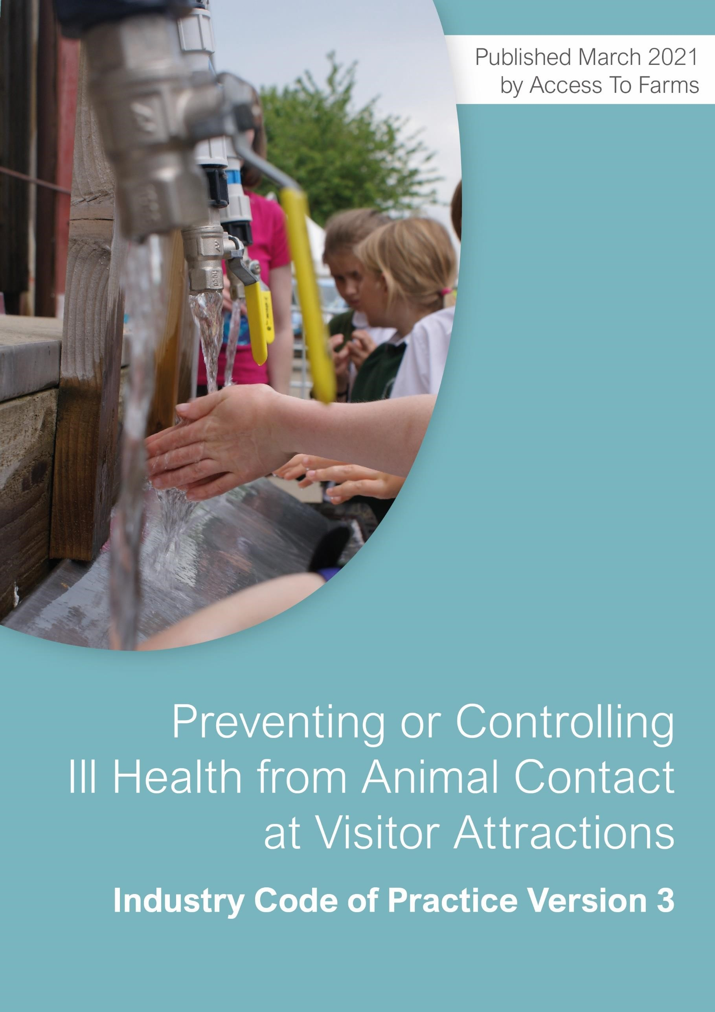

**Table of Contents**

Access to Farms members 3

Introduction 4

Chapter 1: Considering risk 7

Chapter 2: Guiding principles 9

Chapter 3: Planning and organising 11

Chapter 4: Risk assessment 14

Chapter 5: Practical control measures 21

Chapter 6: The role of information in risk control 39

Chapter 7: Advice to teachers and others who organise visits for children 42

Chapter 8: Incident reporting and investigation 44

Chapter 9: Dealing with a major incident 46

Chapter 10: The law and visitor safety 47

Appendix 1: Checklist 51

Appendix 2: Sources of information 64

Published by Access to Farms March 2021

# Access to Farms members

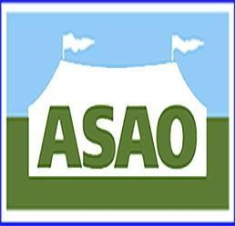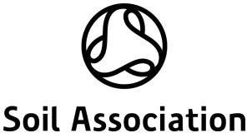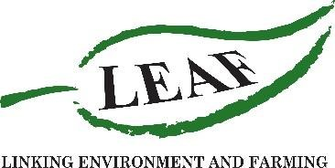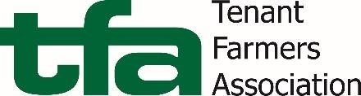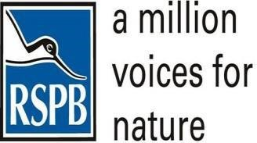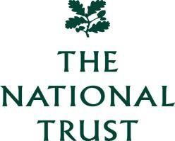

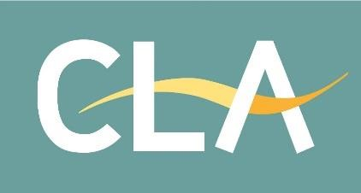

# INTRODUCTION

Every year millions of people visit premises where members of the public, particularly children, are encouraged to view or touch animals.

**The purpose of this Code of Practice is to help ensure visitor health and safety by providing sensible, practical and proportionate guidance on preventing or controlling ill health at visitor attractions.**

This Code of Practice has been produced by the industry and is aimed at the owners, operators and managers of such visitor premises.

It provides guidance, including pictures, of practical measures that you can apply at your premises to help you comply with the law and keep visitors safe. The examples are from businesses, ranging from conventional farms that open to the public for one day a year to attractions that may cater for hundreds of thousands of visitors each year.

“The Health and Safety Executive was consulted in the production of this publication. It endorses the sensible, proportionate, reasonable and balanced advice to owners on managing visitor health and safety set out in the Industry Code of Practice.”

Health and Safety Executive

'The Chartered Institute of Environmental Health supports the adoption and promotion of this Industry Code of Practice and believes that compliance with these standards will be the means to minimise risks to health from visitor contact with animals."

### Background to this Industry Code of Practice

This Industry Code of Practice is based on guidance from the Health and Safety Executive (HSE) Agriculture Information Sheet No 23(rev2) ‘Preventing or controlling ill health from animal contact at visitor attractions*’* (AIS23), which has been withdrawn. Public Health England (PHE), (now National Institute for Health Protection),set up an Independent Investigation Committee chaired by Professor Griffin the report of which, ‘Review of the major outbreak of *E. coli* O157 in Surrey, 2009’ was published in June 2010 and can be found at:

[https://www.gov.uk/government/publications/escherichia-coli-e-coli-o157-report-and-recommendationsfrom-2009-godstone-incident](https://www.gov.uk/government/publications/escherichia-coli-e-coli-o157-report-and-recommendations-from-2009-godstone-incident)

The proposal to develop this Industry Code of Practice to replace existing HSE guidance was discussed with Professor Griffin and the Advisory Committee on Dangerous Pathogens prior to publication of Version 1 of this guidance. The report produced by Professor Griffin was also considered in the production of this guidance.

This Industry Code of Practice was produced by the Access to Farms partnership which includes representatives of a number of organisations whose members encourage visitors, especially children, to visit their farm attraction, farm or other attraction to view, touch or pet animals.

These visits play a valuable part in the education and development of children and young adults, and provide an enjoyable experience for many people. It is uncommon for members of the public to become ill as a result of such visits. However, there have been a relatively small number of reported cases of serious ill health involving members of the public resulting from exposure to micro-organisms such as *E.* coli O157 and *Cryptosporidium* carried by animals.

As with most activities, visits to farms and farm attractions can never be considered free from risk. However, we believe it is possible to reduce the levels of risk and still provide a valuable and enjoyable recreational and educational experience.

### Premises covered by the Code of Practice

These include animal visitor attractions such as:

* Farm attractions such as open farms and farm parks.
* Animal contact enclaves within other attractions, including those at zoos.
* City farms or other educational establishments.
* Working farms with livestock that occasionally open to the public, e.g. for school visits or to participate in Open Farm Sunday or similar events.
* Rare breed and rescue centres.
* Agricultural shows or country fairs where livestock are present.
* Travelling menageries or mobile petting enterprises.
* Other similar visitor attractions at which the public have contact with animals.

Whilst the general principles covered in this document are equally applicable to zoos, specific guidance on managing zoonotic disease (disease passed from animals to humans) in zoos is contained in HSE guidance [Managing zoonotic risk in zoos and wildlife parks.](http://www.hse.gov.uk/pubns/books/hsg219.htm)

**This Code of Practice does not apply to the following destinations except where they may have an animal contact enclave:**

* Moors and mountains
* Historic properties
* Forests
* Way marked trails
* Waterways
* Open countryside
* Visitor centres
* Nature reserves
* Footpaths
* Country parks
* Archaeological remains

For these settings, guidance in the [Managing Visitor Safety in the Countryside: Principles and Practice](https://vscg.org/publications/managing-visitor-safety-in-the-countryside)  booklet is applicable. This guidance is produced by the Visitor Safety in the Countryside Group.

This Code of Practice describes the measures that need to be taken to protect visitors. It does not directly address the health and safety of staff, including employees, volunteers and helpers. Nor is it aimed at premises that offer work experience where children come to carry out work activities. It is also not intended to address premises where agricultural or horticultural activities are undertaken by members of the public such as allotments on city farms and similar premises. Premises still have a duty to comply with legal obligations to protect these people and risk assessments for the activities they undertake will need to be carried out. Premises covered by this guidance may also need additional precautions to protect persons other than visitors depending on the activities that they are carrying out.

**There are several reasons for managing visitor safety:**

**Moral:** First and foremost we want our visitors to return home happy and satisfied with their experiences. We have a moral obligation to consider their health and safety and protect them from unnecessary or unreasonable risk.

**Legal:** We have legal duties to ensure the safety of those we do not employ but who are affected by our work—our visitors. These duties are explained in more detail in Chapter 10.

**Financial:** We need to demonstrate that all reasonable and practicable steps have been taken to reduce the risks, thereby reducing unnecessary costs arising from implementing inappropriate or disproportionate health and safety measures.

**Reputation and authority:** We cannot create an environment that is free from all risk. However, we must demonstrate to the public, regulators and government that we have done all that is reasonably practicable and within our powers to control or minimise the risks down to acceptable levels. If there is a zoonotic outbreak, we are then in a much better position to defend our position and retain public trust.

**Business:** Attracting and satisfying visitors is fundamental not only to the business in question but to many of our businesses. Creating a healthy and safe environment is essential to attract visitors and therefore makes good business sense. Any outbreak would have serious effects on the whole industry.

**Education:** There is an educational benefit from demonstrating how good practice results in healthy and safe visitor experiences, with potential transferable learning value to our visitors.

This Industry Code of Practice covers the building blocks of visitor risk management and aims to improve standards across the industry whilst promoting consistent enforcement by the regulators.

Subsequent chapters deal with specific areas of risk management. Further information on risk management is available at: [https://www.hse.gov.uk/pubns/books/hsg65.htm.](https://www.hse.gov.uk/pubns/books/hsg65.htm)

# CHAPTER 1: CONSIDERING RISK

Consideration of risk is important at several levels:

### Potential risk to society

* Reduction of educational and development opportunities. Many children and young adults derive great educational and developmental benefit from visiting our sites, learning through experience.

**Potential risk to the individual:**

* Personal illness or death
* Long term effects of illness
* Loss of employment, income, or educational opportunities
* Impoverished experience
* Increased costs
* Passing disease onto relations and friends.

It is important to understand how people view and accept risks.

People are less likely to be tolerant of risk when:

* They don’t have it explained to them.
* They are exposed to the risk whether they want to be or not (involuntary exposure).
* They have no control over the outcome.
* There is uncertainty about what could happen and its likelihood of happening.
* They have no personal experience of the risks involved (fear of the unknown).
* It is difficult to imagine the level of exposure to risk.
* There is potential for a major catastrophe (even though the risk of it happening may be low, should it come about the consequences would be severe).
* The benefits of taking the risks are not clear.
* They are exposed to the risks but others get the benefits.
* The potential illness would result from human failure.
* It involves vulnerable groups including children.

Some of these factors account for people’s common misconceptions when asked to rank the relative safety of road, rail and air travel. There is often a mismatch between an individual’s perception of risk and that deduced from risk assessment.

**Potential risk to your organisation:**

* Damage to your reputation and that of other providers.
* Loss of income if visitors don’t come because they perceive that the risk of harm is too great.
* Civil claims arising from visitor illness, leading to financial loss.
* Prosecution and penalties for breaches of criminal law.
* Impact on the morale and esteem of employees.

Adverse outcomes like these arise from either a failure to recognise and deal with a hazard or through making the wrong response. Our aim is to have the best of both worlds—to introduce risk control measures that are sufficient to safeguard visitors, but do not lessen the attraction.

**What are the animal-related ill health risks at visitor attractions?**

All animals naturally carry a range of micro-organisms, some of which cause no illness in the animal but can be transmitted to humans. Diseases passed from animals to humans are known as zoonoses. Some zoonotic diseases may cause ill health; in some cases the diseases may be severe or life threatening. Equally, some are more amenable than others to treatment, and some may leave lasting ill health.

A range of zoonotic diseases can be acquired from animal contact at visitor attractions including:

* Shiga toxin-producing *Escherichia coli (STEC) (including E. coli* O157)
* *Cryptosporidium parvum*
* *Chlamydia abortus*
* *Chlamydia psittaci*
* Toxoplasmosis
* *Salmonella* spp.

**How do people become infected?**

People can become infected with micro-organisms through consuming contaminated food or drink, through direct contact with contaminated animals, by contact with an environment contaminated with animal faeces or by being bitten. Very low numbers of micro-organisms can cause human infection.

**How safe is a visit to an attraction?**

Given that an estimated 20 million people visit such attractions each year, we consider the risk of infection to be low if good controls are in place. The risk may be higher where proper control measures are not put in place.

Public Health England found that there were 105 outbreaks of gastrointestinal disease linked to petting farms between 1992 to 2017 in England and Wales. Although the overall risk of infection is low in light of the number of farm visits each year, these outbreaks—over a 25-year period—led to 1,676 people becoming infected, of whom 130 were hospitalised. Illness ranged from mild through to severe diarrhoea and occasionally more serious conditions. Most of these outbreaks were caused by Cryptosporidium (56 per cent) or E. coli O157 (42 per cent).

Zoonotic disease can be very serious for those affected, particularly young children and the elderly. However, the risk needs to be seen in the context of an historically very low incidence of reported infection at visitor attractions where the public are encouraged to view or touch animals. Although the number of reported cases of zoonotic diseases varies from year to year, there is no evidence to suggest a substantive increase in the prevalence or incidence of infection in Britain.

# CHAPTER 2: GUIDING PRINCIPLES

This chapter sets out the overarching principles that we use to guide us when deciding what actions to take to reduce the risk of zoonotic diseases to visitors. Subsequent chapters expand on these principles.

## RISK CONTROL

***Assess risks***

Every attraction should carry out a site-specific risk assessment.

A risk assessment would typically involve: identifying how the public could be exposed to microorganisms (or other risks on the farm); the likelihood of it happening; the possible consequences, and what measures need to be taken to reduce the risks to an acceptable level. The risk assessment should also indicate the need to carry out further assessment after a specified interval, or when there is a change in the circumstances at the attraction or the activities provided. It should be reviewed regularly to verify risk mitigation strategies are in place and are working. The risk assessment should be acted upon and suitable controls put in place.

***Monitor the behaviour and experiences of visitors to review visitor safety plans.***

Learn from experience of incidents and near misses. Asking visitors about their experiences through visitor surveys is one way of collecting valuable information on their experiences and how effectiveness of control measures. Have systems in place for accident reporting and investigation, and for letting others know what lessons you have learned. Monitor changes in the number and type of visitor to ensure risk controls remain valid.

## AWARENESS

***Ensure that your visitors know the risks they face.***

Visitors should be made aware of the risks they face and have the chance to decide whether to accept them.

***It is extremely important that you inform and educate your visitors about the nature and extent of hazards including what zoonotic disease is, how it can affect people, how it is communicated, the risk control measures in place on your site, and the precautions that they themselves should take.***

Risk can be controlled through information and education as well as physical measures. People on organised visits, e.g. school trips, can be made aware of hazards in advance through their organisers. Information can be included on the attraction’s website and on-site maps/plans given to visitors on arrival. Signs and notices at entrances and around the site are also an important means of communicating information. However, it is not sufficient to rely solely on written communications such as signage to communicate important risks and control measures. Reliance on signage alone has been shown to be inadequate to control risk. Providers have a duty to ensure that visitors are aware of the risks and control measures. Verbal explanation of the risk posed by animal contact may another way of informing visitors of the risks and control measures on site, either as visitors enter the premises or as they enter “animal contact” areas.

## RESPONSIBILITY

***It is reasonable to expect visitors to exercise some degree of personal responsibility.***

It is reasonable to expect visitors to follow simple instructions made known to them verbally by staff, on leaflets and on signs—such as washing hands before eating, drinking or smoking and washing hands after leaving contact areas. Risks must be made known to visitors and instructions clearly given. Some visitors may not be able to read, or may speak a different language, and this should be considered when deciding on ways to convey important information. Written communication alone should not be relied upon as the sole means of communicating important health and safety information.

***It is reasonable to expect parents, guardians and leaders to supervise people in their care but the provider retains supervisory responsibilities.***

Parental/carer responsibility should include, for example, supervising children when washing their hands and preventing young children sucking their fingers immediately after handling animals or their environment. Supervising staff in “animal contact” areas should, where necessary, prompt visitors to wash their hands after contact with animals.

# CHAPTER 3: PLANNING AND ORGANISING

This chapter introduces a framework for planning and organising your approach to visitor safety and ensuring that it integrates with other management activities.

### Elements of an organisation’s Visitor Safety Plan

Whatever the size of organisation and resources available, establish a policy for visitor safety and have a strategy for its implementation. Set clear objectives and have a good management plan to achieve them. Learning from experience is important. You should review the outcomes and, if necessary, make changes to improve things. Where businesses employ 5 or more people the health and safety policy should be in writing.

Visitor safety management is no different to other management processes that demand a systematic approach, one example is shown in the diagram below.



**Review**

Refer to Guiding Principles



**Do**

Implementation

and Operation



**Plan**

Policy and

Planning



**Act**

Learn and Improve



**Check**

Performance

Monitoring

**1. Plan**

### Policy and strategy development

*Developing a policy for visitor safety management and promoting a strategy for its achievement will ensure effective use of your organisation’s resources as well as ensuring visitor safety*.

An effective policy will:

* Demonstrate the commitment of senior management to visitor safety.
* Integrate visitor safety management with other relevant organisational policies and management activities throughout the organisation.

An effective strategy will:

* Clearly set out how your organisation is structured to deal with visitor safety issues.
* Show where you are now, where you want to be, and set out the steps to get there.
* Identify the resources, in money and staff time, necessary to achieve the objectives.

### Planning and organising

*Develop plans for visitor safety management at appropriate levels, depending on the size and structure of the organisation.*

The types of organisation involved with visitor attractions are varied, ranging from small farms that open to the public one day a year to large enterprises attracting 250,000+ visitors each year. It is reasonable to expect a large attraction to have a detailed safety plan. For a small farm which opens one or two days per year, a site-specific risk assessment is enough.

*Define clear roles*.

State who is responsible for carrying out each task, producing overall visitor safety plans, undertaking individual risk assessments and acting on the findings. Be clear who will audit the process and review progress.

**2. Do**

### Implementation and operation

*List the hazards that your visitors might encounter and assess the risk that they might be harmed.*

Risk assessment is central to visitor safety management and is covered in more detail in Chapter 4, control measures are covered in Chapter 5. Take care when using generic risk assessments or guidance. They will need adapting to take account of local circumstances. It is essential to use the knowledge of staff and users who are familiar with the site. Where businesses employ 5 or more people, the risk assessment should be recorded.

Most importantly, you should have systems in place to ensure that you implement the control measures required to keep people safe. Some controls will be a single fit e.g. double fencing (with some level of monitoring to ensure that they remain effective), other controls will be ongoing e.g. cleaning or supervision. It is important that staff are trained in and understand the control systems in place.

**3. Check**

### Performance monitoring

*Plan a programme of inspection and keep clear records of those inspections and of any actions that you take as a result of inspections.*

A key step in risk management is having a system of inspection and monitoring to regularly check that control measures are still in place and effective e.g. that people are carrying out their roles properly, contact areas are supervised, cleaning is carried out on time and to standard etc. Recording the inspections carried out provides an audit trail of the actions that you have taken to keep people safe.

*Learn from incidents and near misses*.

Incident and accident data is a valuable indicator of risk and provides a measure of performance. Do not ignore near misses, encourage staff to report them and treat them as an opportunity to learn from something that did not quite happen, this time.

**4. Act**

### Learn and improve

Act on the results of your monitoring. Learn from the information that you have gathered and where necessary act to make improvements. Incorporate mechanisms into routine work that allow feedback to be used to improve services and safety for visitors, or to explain why no changes are being made. Review risk assessments and work instructions to ensure that they remain appropriate. Take account of visitor and worker feedback on what works and what doesn’t and decide whether changes are needed,

**5. Review**

### Review against guiding principles

*Periodically review the whole management system to ensure that it is effective and up to date.*

Review is a key part of a management process. Unless the whole management system is periodically reviewed it can become out of date. Organisations, including their employees, competencies, and ways of working, can change over time. Identify any lapses or failures in the management system and fix them.

### References and further information

Recognised Management Systems:

* BS 45002-0:2018 - Occupational health and safety management systems. General guidelines for the application of ISO 45001
* HSG65 – Managing for health and safety (HSE)

# CHAPTER 4: RISK ASSESSMENT

There is a checklist table at Appendix 1 which sets out some commonly found issues that may require consideration. However, each site is different, so it is important that your risk assessment reflects the risks on your site.

This chapter sets out the steps necessary for successful risk assessment. This includes the information required, a suggested methodology, and what should be recorded.

### Assessing risks to visitors

There is no universally accepted format for carrying out risk assessments. The HSE recommends a five-step approach for risk assessment in the workplace. We have used this model as an example. Although in the discussion below, zoonotic risk is focused upon when explaining how to carry out a risk assessment, other hazards which may be on site e.g. workplace transport, falling objects etc should also be considered and addressed where appropriate.

1. Identify the hazards.
2. Consider who might be harmed and how.
3. Evaluate the risks and decide whether the existing risk control measures are adequate or whether more should be done.
4. Record your findings and implement them.
5. Review your assessment and update if necessary.

* + **Hazard** is anything with the potential to cause harm.
  + **Risk** is the likelihood, high or low, that somebody will be harmed by the hazard, the severity of the harm and the number of people who might be hurt.
  + **Risk control measures** are precautions to make an incident less likely to occur and/or the results less severe.

Further information on risk management can be found on the HSE website at: [http://www.hse.gov.uk/risk/index.htm.](http://www.hse.gov.uk/risk/index.htm)

**5 steps to risk assessment**

### Step 1 – Identify the hazards

The first step in the risk assessment process is to identify the hazards. Animals and the microorganisms that they carry are both hazards that can pose a risk to people.

All animals naturally carry a range of micro-organisms, some of which can be transmitted to humans, in whom they may cause ill health, which in some cases may be severe or life threatening. The majority of zoonotic outbreaks on farms are caused by either E. coli O157 or Cryptosporidium.

*STEC (including E. coli O157)*

One organism that may be carried by some farm animals is the Shiga toxin-producing bacterium *E. coli* O157. *E. coli* O157 can cause serious illness, especially in young children and the elderly. The illness can lead to kidney failure and may occasionally be fatal.

You should assume that your animals carry *E. coli* O157 even if they have no signs of this.

Cattle, sheep and goats are the main recognised carriers of *E. coli* O157. The organism may occasionally be found in other animals, especially amongst the mixed species often present at visitor attractions. These include pigs, chickens, horses, donkeys, deer, llamas and alpacas. Farm dogs and wild rabbits can pick up the infection from an infected environment. Infection can also occur in birds such as wild geese. The organism is primarily transmitted through contact with animal faeces (dung).

It may also be transmitted by contact with saliva derived from animal grooming activities.

*Cryptosporidium parvum*

*Cryptosporidium parvum* is a microscopic parasite predominantly carried by calves, lambs, deer and goats that can cause severe diarrhoea in young children and the elderly. It is capable of surviving for a long time in the environment.

*Chlamydia abortus*

Visitors may also be exposed to *Chlamydia abortus*, the agent of enzootic abortion and *ovine chlamydiosis* in humans*.* This bacterium is carried by sheep and possibly goats. In humans, it may cause abortion in pregnant females. It can also cause flu-like illnesses.

Other zoonoses that may be present at visitor attractions include:

* *Salmonella* spp.
* Orf
* Q fever
* Ringworm
* *Campylobacter* spp.
* Leptospirosis
* Toxoplasmosis
* Chlamydia psittaci

### Step 2 – Consider who might be harmed and how

People can become infected with micro-organisms by consuming contaminated food or drink, through direct contact with infected animals, by contact with an environment contaminated with animal products such as faeces, or by contact with animal saliva.

Very low numbers of micro-organisms can cause human infection.

Anyone can be infected, but children and the elderly are the most vulnerable. Young children are particularly at risk because they are most likely to put contaminated fingers or items in their mouths (including thumb sucking, nail biting and dummies/toys). Pregnant women, and people with weakened immune systems, are also at risk. Only small numbers of the organism are required to cause illness, so just because something (an animal or an object) is not visibly contaminated with faeces, this does not necessarily mean it is free from risk.

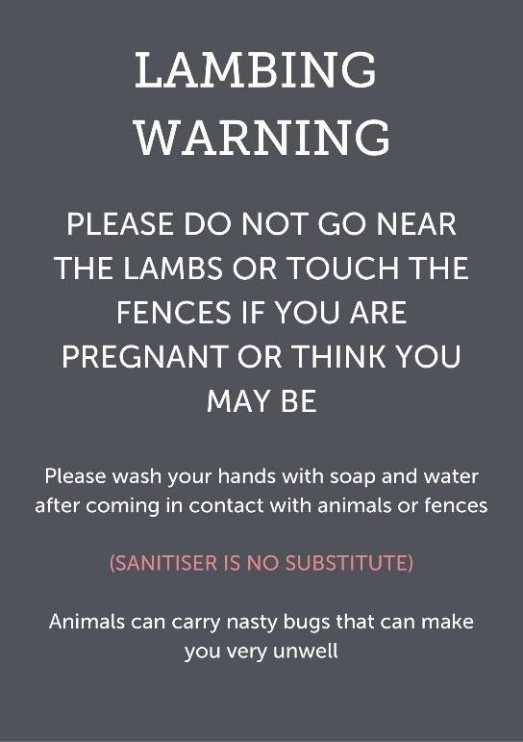

**Left: Sign advising**

**women**

**about possible health risks.**

**Sign**

**s**

**can certainly help but**

**they should not be relied upon**

**as the sole means of**

**communication.**

Infection can occur when people come into contact with animal faeces or saliva (even very small amounts) by:

* Touching or kissing animals in petting areas or during bottle-feeding.
* Feeding, stroking or touching animals through gates or pens.
* Touching gates, or animal pen divisions, or other structures contaminated with faeces.
* Picking up contaminated feed from the floor.
* Removing contaminated footwear or clothing.
* Eating, drinking and smoking with contaminated hands.
* Using contaminated play equipment.
* Touching personal items taken on to the premises that have become contaminated, e.g. dropped toys or dummies and pushchair wheels.
* Being bitten.

### Step 3 – Evaluate the risks and decide whether the existing precautions are adequate or whether more should be done

The level of overall risk depends on a combination of factors: the likelihood of harm arising, the severity of the harm, and the number of people who might be affected.

When undertaking your assessment you should be aware that:

* All animals (including birds) carry micro-organisms such as *E. coli* O157 that could represent a hazard to human health. Animals carrying infection can still appear clean and healthy.
* Ruminants (e.g. cattle, sheep and goats) carry *E. coli* O157.
* *E. coli* O157 is also found in a range of other animals and birds.
* Although tests are available to detect the presence of *E. coli* O157 and other micro- organisms, a negative test result does not guarantee the animal is free of infection.
* *E. coli* O157 may be introduced to your premises at any time by new stock, wild birds and animals, or by visitors.
* Young stock, stock under stress, pregnant stock or stock that are unfamiliar with people are more likely to excrete micro-organisms such as *E. coli* O157.
* Other animals on the premises, including pets, may acquire the bacterium through contact with faeces etc.
* Some groups of people are potentially more vulnerable to the effects of infection than others.

### Control measures

Control measures are actions that need to be taken to prevent or reduce exposure to a substance hazardous to health, in this case micro-organisms. Such measures include the layout of the premises (including topography), the cleaning of the premises, provision and use of washing facilities, supervision, information, and signage. A combination of control measures will be necessary to protect the health of visitors. To be effective, these measures should be practical, workable and sustainable. They should be reviewed on a regular basis.

### Controlling the risk

In order to minimise and control the risk you should concentrate on the following:

* Establishing premises layout and routes, including segregating areas to which visitors should not have access.
* Defining, segregating and clearly identifying **“animal contact” areas.** “Animal contact” areas are any areas of the attraction where visitor contact with animals is intended or allowed.
* Defining, segregating and clearly identifying animal **“non-contact” areas**. “Non-contact” areas are any areas where visitor contact with animals or potentially contaminated fencing must be prevented. Mandatory areas which fall into this category include eating areas, playing areas and smoking areas.
* Defining, segregating and clearly identifying **“look and see” areas**. “Look and see” areas are any areas of the attraction where visitor contact with animals may not be intended or allowed, but is still possible, e.g. fields, pens or paddocks containing animals where it is possible for visitors to

make contact with the animals if the animals are close to the fence.

* Providing adequate and suitably located washing facilities.
* Providing visitor information, instruction and signage.
* Ensure that visitors are made aware of the risks and control measures provided.
* Providing training and supervision of staff.
* Establishing livestock management procedures including management of bedding, sick/pregnant/stressed animals and veterinary input.
* Controlling manure/run-off and compost heaps.
* Carry out monitoring to ensure that control measures are effectively implemented.

The above issues are discussed in more detail in the following sections.

The diagram below shows the risk pathway for micro-organisms such as *E. coli* O157 and demonstrates how the pathway can be broken by control measures.

## The risk pathway for micro-organisms

**Infected**

**animal**

**X**



Infection in some

individuals



Ingestion of

micro

-

organism



Micro

-

organism

e.g. E.

*coli*

in

0157

faeces/saliva



**Infected**

**animal**



**X**

**Denotes point**

**where pathway**

**can**

**be broken**

Clean site & avoidance of

faecal contact



**X**



Contamination of

hands



Contact prevented e.g.

by

double fencing

Effective

handwashing/hygiene



**X**



Contamination of

environment



### Step 4 – Record your findings and act on them

If you employ 5 or more people, the risk assessment should be recorded.

You must be able to demonstrate that you have a system in place to spot hazards, but you are not required to record every possible type. Concentrate on the significant hazards that could result in serious harm, or affect several people.

You should keep a record of your assessment where any significant risk is identified, whether or not any further precautions are proposed. This will be useful for later review and for sharing the findings with your site staff.

When writing down your results, keep it simple. A risk assessment is not expected to be perfect, but it must be suitable and sufficient. You need to be able to show that:

* A proper check was made.
* You considered who might be affected.
* You dealt with all the significant hazards and have taken into account the number of people who could be affected.
* That you have taken reasonable precautions to control significant risks, and the remaining risk is low.
* You involved your staff or their representatives in the process.

If, like many businesses, you find that there are quite a lot of improvements that you could make, big and small, then you will need to prioritise. Make a plan of action to deal with the most important things first. Health and safety inspectors acknowledge the efforts of businesses that are clearly trying to make improvements.

A good plan of action often includes a mixture of different things such as:

* Deal with things that pose the greatest risk first.
* Where possible implement long-term solutions over temporary fixes.
* Long-term solutions to those risks most likely to cause accidents or ill health.
* Long-term solutions to those risks with the worst potential consequences.
* Arrangements for training employees on the main risks that remain and how they are to be controlled.
* Regular checks to make sure that the control measures stay in place.
* Allocating clear responsibilities – who will lead on what action and by when.

Remember, prioritise and tackle the most important things first. As you complete each action, tick it off your plan.

**Step 5 – Reviewing risk assessments**

You should regularly review risk assessments as a matter of course e.g. annually.

In addition, they should be reviewed immediately after any significant incident or near miss and following significant changes to the site, the animals kept, visitor activities or working practices on site. Such changes may necessitate additional and/or alternative risk control measures.

The date and reason for the review and the revised findings should be recorded and retained for future reference.

**In summary:**

* Identify the hazards on your site.
* Know who is using your site and what they are doing there.
* Think about what accidents could happen (or have happened) and how they might be caused.
* Decide if current risk control measures are adequate or more needs to be done.
* When introducing new risk controls choose the most effective ones that are practicable bearing in mind their impact on benefits.
* Record your findings and review your risk assessments on a regular basis.

# CHAPTER 5: PRACTICAL CONTROL MEASURES

**This chapter sets out some reasonably practicable measures that you should have regard to when controlling risk on your site.**

### Premises layout and routes

You should:

* Decide which areas you do and no not want visitors to have access to on your site. • Your farm area is likely to be a mixture of designated “**animal contact**” and “**non-contact**” areas. Be aware of “**look and see**” or areas where animal contact may not be allowed or intended but is still possible. Control measures should be put in place for “look and see” areas based on the level of risk.
* In “**non-contact**” areas, your visitors should **not be able** to contact higher risk animals such as ruminants, pigs, chickens etc or their faeces or potentially contaminated equipment such as fences.
* Make sure routes around the premises prevent visitors from entering prohibited or non-access areas, e.g. places where work is going on or where manure is stored.
* Consider areas of potential contact such as single fenced fields on the visitor route.
* Consider how you will prevent entry to prohibited or non-access areas. For example, providing suitable fencing and warning signs.
* Ensure that safety risks on visitor routes and access areas are assessed and controlled e.g. being kicked / bitten by animals, vehicle movements, falling objects etc.
* Ensure that visitors pass by washing facilities as they leave any “animal contact” area, before they access eating and play areas and before leaving the premises. Washing facilities should be located so that they are convenient for visitors to use when passing through these three areas or when leaving site. Washing facilities should also be suitably signed.
* Avoid directing visitors across tracks or routes regularly used by stock and farm vehicles. If this is not possible, make sure visitors do not have to walk through any build-up of faeces, liquid effluent, or soiled bedding material. For example, regularly clear or clean routes used by livestock or when cleaning out pens etc. If necessary, consider providing duckboards or similar so that visitors avoid contaminating their footwear.
* Keep the premises as clean as practicable and ensure areas to which visitors have access are free from any build-up of faeces.
* Consider producing a site plan showing key areas such as visitor routes, “animal contact” areas, “look and see” areas, play areas, eating areas and wash stations. Incorporating a site plan and key health and safety information into visitor leaflets and boards around the site is a useful method of giving visitors the information that they need.

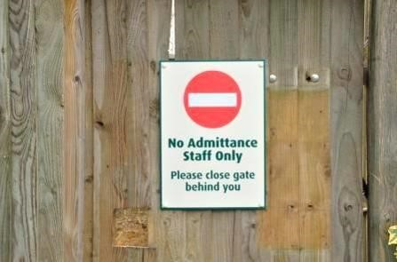

**Left: Clear sign**

**on locked gate**

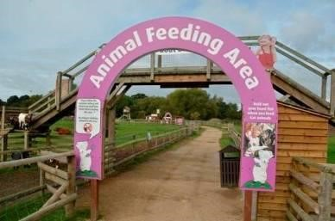

**Using fields previously used for grazing**

Take the following precautions if you intend to use fields that have been used for grazing or

keeping stock for recreational activities e.g. picnicking, camping or play area:

•

Keep farm animals off the fields for at least three weeks prior to

use, but be aw

are that

harmful micro

-

organisms can persist for many weeks in faeces and on pasture.

•

Remove any visible droppings, ideally at the beginning of the

period.

•

Mow the grass, keep it short and remove the clippings before the fields are used for

recreation.

•

Keep farm animals off fields during use.

•

Always wash hands before eating, drinking and

smoking.

•

Ensure adequate supervision of children, particularly those aged under

five.

**Left: Well signed**

**entrance to animal**

**feeding area**

### “Animal contact” areas and “look and see” areas

You should:

* Identify all areas on your site where contact with animals is allowed or intended e.g. petting or feeding areas. These areas should be treated and managed as **“animal contact” areas**.
* Identify all **“look and see” areas** on your farm. “Look and see” areas are any areas of the attraction where visitor contact with animals may not be intended or allowed, but is still possible, e.g. fields, pens or paddocks containing animals where it is possible for visitors to make contact with the animals if the animals are close to the fence.

Any “look and see” areas must be considered as part of the site-specific risk assessment to determine appropriate control measures.

Each “look and see” area on your site may pose different levels of risk to people, so each may need addressing separately in the risk assessment. All “look and see” areas should be controlled according to the level of risk they pose to visitors.

You should be able to identify from the risk assessment, the level of risk and the control measures in place, or required, for each “look and see” area on your site.

Some of the factors which may determine the level of risk from “look and see” areas include:

* The number of visitors who may walk by the “look and see” area.
* The type and age of animal that the “look and see” area contains.
* The likelihood that visitors will (even with prohibitive signage in place) make contact with the animals in the “look and see” area to feed or pet them.
* The size of the “look and see” area and the number of animals that it contains.
* The risk of contamination from “look and see” area fencing.
* Other control measures such as supervision of the area, signage, nearby hand-washing facilities.
* Any other issues specific to your site.

Where premises wish to ensure that visitors do not make unintended contact with animals or potentially contaminated fencing in “look and see” areas, the “look and see” area could be double fenced. If properly used, double fencing should prevent visitor contact with animals and potentially contaminated fencing while still allowing visitors to look and see the animals, therefore not impacting on the visitor experience.

Depending on the level of risk posed to visitors by the “look and see” area, double fencing may in any case be a reasonably practicable control measure. This should be considered when assessing and applying control measures.

* Decide which animals are suitable for “animal contact” and “look and see” areas. Sick or injured animals should be excluded from contact with the public.
* Not allow the public to enter pens where animals are housed (this is because faeces or contaminated bedding will be underfoot and may contaminate visitors, their shoes and clothing. In addition visitors may themselves carry infections on their footwear that could put your animals at risk).

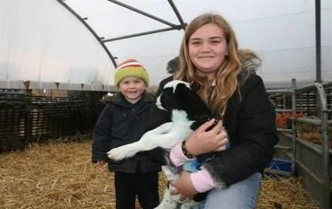

Visitors should not be allowed into the pens where animals are kept. However,

visitors can be allowed to enter pens or enclosures specifically designed for the

handling of animals, such as pens in which lambs are brought into for feeding or

petting. These

areas should be closely supervised and be near to washing facilities.

Staff should remind visitors to wash their hands after animal contact e.g. feeding

the lambs. The staff should also remove any recent faecal contamination from the

pen immediately and di

sinfect the area.

**Left: Do not**

**allow visitors**

**to enter pens**

**where animals**

**are housed**

Ensure that all feeding of animals (especially ruminants) where there is potential for animal contact is supervised and visitors are then directed to supervised hand washing areas.

* Ensure adequate and suitable washing facilities are available and are used by visitors when leaving “animal contact” areas. Washing facilities should be located near to the exit points of “animal contact” areas and should be well signposted. Staff supervising “animal contact” areas can also verbally remind visitors to wash their hands when leaving “animal contact” areas.
* Ensure that entry to “animal contact” areas is controlled. Unsupervised children should not be able to access the area.
* Ensure fencing and other barriers are regularly inspected and properly maintained.
* Ensure that “animal contact” areas where visitors stand or walk are as free as possible from any faeces. Put in place measures to prevent contamination from liquid manure or surface run-off where necessary.
* Regularly clean and disinfect pen divisions and gates in “animal contact” areas where visitors can touch them. A variety of cleaning methods are available. Not all disinfectants are suitable so take advice from your vet. Putting in place a schedule of cleaning will help to ensure that this is done.
* Don’t allow faeces to remain on and contaminate walkways or other areas used by the visitors.
* Don’t allow contaminated bedding or run-off material to contaminate walkways or other areas used by visitors. Solid boarding at the base of pens can be used to prevent spillage onto walkways.

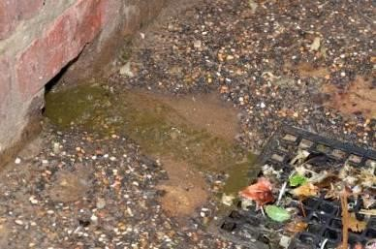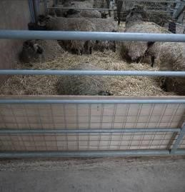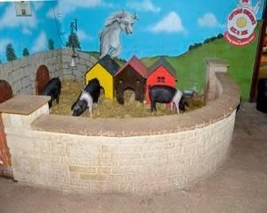

**Left: Do not**

**allow run**

**-**

**off to contaminate**

**walkways**

**Below:**

**Retain all**

**bedding and faecal**

**material within the**

**pens**

Take all reasonably practicable action to prevent visitors from eating (including sweets, gum and ice cream), drinking, putting contaminated items in mouths (including dummies, pens and pencils), and smoking when they are in “animal contact” areas. Signs should be displayed instructing visitors of this requirement.

* Ensure that there is an adequate number of trained staff for “animal contact” areas at all times when they are used by visitors, and that those staff have clear instruction on their role and responsibilities.
* Where eating and play areas are adjacent to areas containing animals, ensure that measures are provided to prevent members of the public touching the animals, e.g. by providing double fencing. This should be positioned at a distance that will prevent visitors reaching through to touch the animals and to prevent animals reaching over or through the fence to contact people.

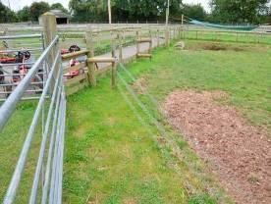

**Above: Example of double fencing, stock**

**and electric fences used together**

**.**

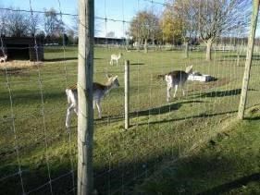

**Above: Example of double fencing, high**

**and low stock fences. Visitors can still**

**view**

**the animals safely**

**.**

## Children can still enjoy feeding animals in “non-contact” areas and “look and see” areas

**Above: Food is allowed to slide down**

**the pipe**

**into the pen for pigs**

**.**

**Above: Food is placed in the trailer and by**

**turning the handle the tractor and trailer back**

**out and the food is tipped from the trailer for**

**the cattle**

**.**

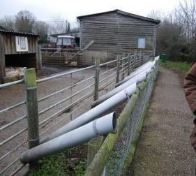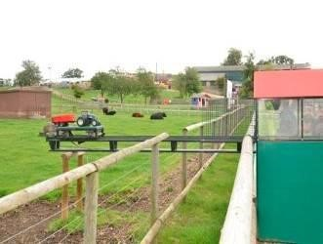

For some “look and see” areas, it may not be reasonably practicable to provide double fencing. This will need to be assessed on a case by case basis but examples include working livestock farms that open very occasionally, such as on Open Farm Sunday. In such cases, the areas should be clearly signed to inform visitors they are entering an area where touching, petting and feeding of animals is not allowed. You should be able to demonstrate that any decision to rely on single fencing and signage rather than double fencing has been properly considered in your risk assessment. Depending on the circumstances and level of risk, for farms opening to the public more frequently, double fencing may well be considered a reasonably practicable control measure for “look and see” areas.

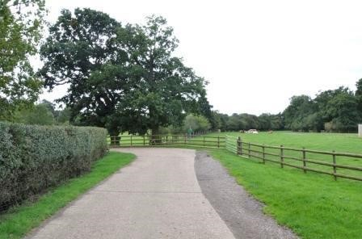

**Left: In low risk**

**areas (e.g. large**

**fields and few**

**animals alongside a**

**walkway) single**

**fencing may be**

**acceptable, but it**

**should still be clear**

**to visitors that they**

**should not touch**

**animals.**

### Eating areas

You should:

* Site eating or picnic facilities away from areas where animals can be contacted, or where windblown contaminated material (e.g. straw from muck heaps) might be present. Preferably site eating and picnic facilities at the end of any farm trail, walk or tour, or outside the main areas of the premises.
* Ensure that visitors have to pass through or by washing facilities before entering eating areas.
* Ensure visitors are advised verbally as well as by signage during the visit and in “animal contact” areas to wash their hands before eating.
* Exclude animals including captive birds from eating areas. They could contaminate eating areas with faeces. Consider wing clipping, double gates into eating areas and adequate fencing to exclude them.
* Ensure that eating areas are kept clean. Putting in place a schedule of cleaning and a recording system will help to ensure that this is done.
* Where eating areas are adjacent to “animal contact” areas, prevent animal contact e.g. by providing double fencing. This should be positioned at a distance that will prevent visitors reaching through to touch the animals and to prevent animals reaching over or through the fence to contact people.
* Provide adequate waste bins and clear discarded food from eating areas to discourage wild birds and rodents from feeding and contaminating the area.
* Locate ice cream and sweet kiosks in the “non-contact” areas of the premises, such as the eating areas or at the exit where visitors have passed washing facilities. Remind visitors using the kiosks, by notices or verbally, to wash their hands before touching or eating purchased food or sweets.

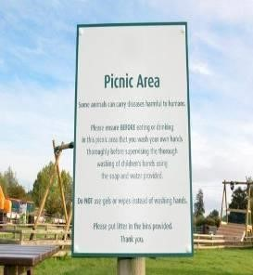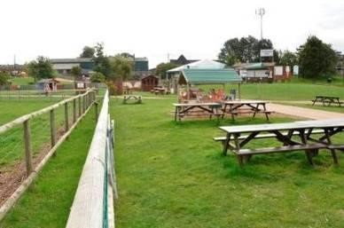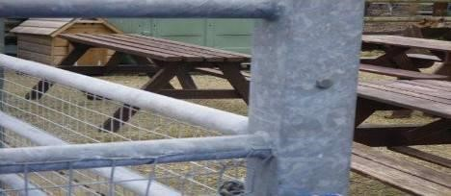

**Left: This is not acceptable.**

**Where eating areas are**

**situated next to**

**“**

**animal**

**contact**

**”**

**areas, animal**

**contact must be prevented.**

**This can be achieved by use**

**of double fencing**

**.**

**Above: Double fencing to prevent contact with animals.**

**This is especially important near to eating and playing**

**areas.**

**Above: Signs reminding**

**visitors to wash hands**

**before eating or**

**drinking**

**.**

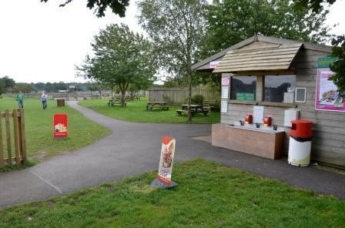

**Left: Washing**

**facilities on side**

**of**

**food**

**kiosk**

### Play areas

You should:

* Site play areas away from areas where animals can be contacted, and preferably at the end of any farm trail, walk or tour, or outside the main areas of the premises.
* Ensure that visitors are advised both verbally and by adequate signage, to wash their hands before and after using play areas.
* Exclude animals including captive birds from play areas. They could contaminate play areas and equipment with faeces. Consider wing clipping, double gates into play areas and adequate fencing to exclude them.
* Where play areas are adjacent to “animal contact” areas, prevent animal contact, e.g. by providing double fencing. This should be positioned at a distance that will prevent visitors reaching through to touch the animals and to prevent animals reaching over or through the fence to contact people.
* Ensure that play areas and equipment are designed so they can be cleaned on a regular basis to remove any contamination.
* Ensure that play areas are regularly cleaned. Putting in place a schedule of cleaning and a recording system will help to ensure that this is done.

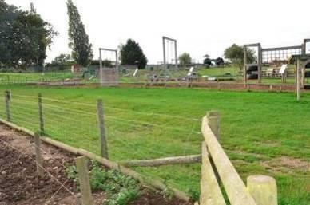

**Left: Double fencing**

**between play areas and**

**areas containing**

**animals**

**.**

### Cleaning footwear, pushchairs, wheelchairs etc

The layout of the premises should be planned to minimise the likelihood of contamination of footwear, pushchairs, wheel chairs etc. Where this unavoidably occurs, you will need to consider providing suitable facilities to allow visitors to clean contaminated footwear and wheels on pushchairs and wheelchairs. The facilities should be arranged to reduce the risk of personal contamination from manure, liquid run off etc. during the cleaning process and be located so that people can easily wash their hands after this has been done. Ideally these facilities should be located close to the exit to the site.

### Washing Facilities

While the primary control measures should focus on reducing and eliminating faecal contamination, the most effective method of removing dirt and contamination remains hand washing with soap and running hot and cold, or warm water followed by hand drying. Soap bars can easily be dropped onto the floor and become contaminated. Liquid soap is a better solution and should be used.

The provision of adequate numbers of washing facilities and their location is crucial to preventing ill health. Facilities can be individual taps and basins, and/or long sinks with a number of running water outlets. If they are not located adjacent or very close to the following areas it is much less likely that they will be used by visitors. In short, handwashing facilities must be located so that they are convenient for visitors to use. They need to be provided and easily accessible at or near:

* Areas where visitor contact with animals is allowed or intended, such as petting barns. If there is a one-way system for visitors through the contact area they should be provided immediately adjacent to the exit. If there is a two-way flow of visitors they should be provided immediately adjacent to entrances and exits. A one-way system may help to ensure that washing facilities are properly used.
* Entrances to eating areas.
* Within reasonable distance to play areas (so that they can be used before and after using the play areas).
* Exits from the premises.
* Any other areas as identified by your risk assessment.

**Are you providing enough washing facilities?**

An acceptable way to estimate the capacity of washing facilities is to:

* Estimate the maximum number of visitors expected or permitted at one time.
* Consider how many visitors will be in “animal contact” areas at any time—you may already limit numbers in these areas to allow visitors time to enjoy the experience with the animals.
* Assess the rate at which visitors will leave contact areas, e.g. in large groups such as school parties or a few at a time.
* Estimate the time taken to wash hands effectively, remembering that a thorough hand wash may take up to two minutes.

If you estimate that, for instance, 30 people will leave a contact area every 15 minutes, and each person will take two minutes to wash their hands, you should provide enough washing facilities for four people to use at one time (30 x 2 divided by 15 = 4). Make similar calculations for other locations around the premises, such as the main exits or entrances to eating areas.

You can supplement permanent facilities with temporary ones at busy times, e.g. just before the summer holidays, in remote areas of the premises, or for short duration events such as country shows or fairs. Portable units can be hired which have heating, lighting and running water.

Providing suitable numbers of washing facilities should be part of the considerations in your risk assessment.

All washing facilities should be/have:

* Accessible by all visitors, i.e. at the right heights for both children and adults or with raised standing areas provided for children. Check these do not create tripping or falling hazards.
* Running hot and cold, or warm water (e.g. mixer taps). It is easier to create soap lather with warm water, and it may encourage visitors, especially children, to wash more thoroughly particularly in cold weather. Warm water supplies should be fitted with a means of restricting the temperature to no more than 43°C to avoid scalding.
* Liquid soap as soap bars can become contaminated.
* A suitable means to dry hands. Paper towels are better as they provide an additional opportunity to remove contamination. Hot-air hand-dryers are also suitable but may lead to queues that discourage visitors from washing their hands. Reusable hand towels are not suitable.
* Properly maintained and cleaned regularly as required, at least daily. A cleaning schedule and recording sheet is a useful way of ensuring that this is done.
* Replenished with paper towels and liquid soap as necessary.
* Open or pedal operated waste bins that are emptied as necessary.
* Arranged so that visitor throughput and/or water overflows etc. do not make the immediate vicinity muddy and put people off using the washing facilities.

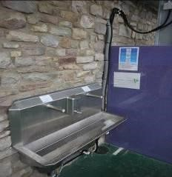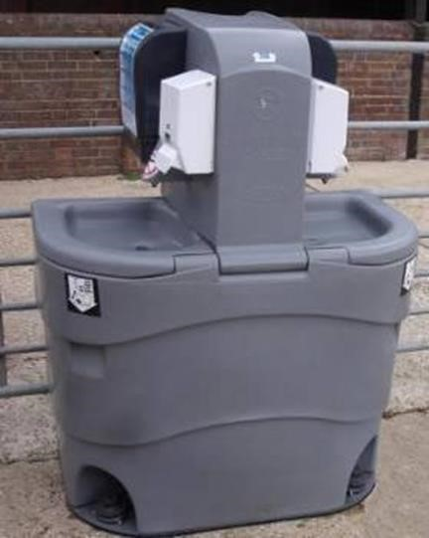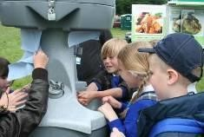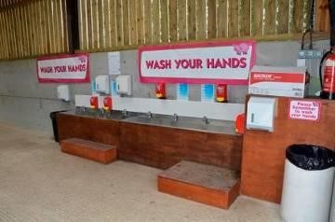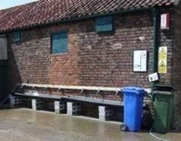

**Above: Two examples of good**

**washing facilities with running**

**water and soap dispensers fitted.**

**Left: Temporary washing facilities**

**fitted by a farmer for short**

**duration events. The troughs can**

**be**

**removed when no longer in**

**use.**

**Above and left: Smaller portable hand wash**

**stations can be bought or hired for short**

**duration events e.g. Open Farm Sunday**

**events over a weekend. If purchased, they can**

**be reused for future**

**events.**

**Left: This is totally unacceptable. Dirty water will be contaminated. Washing facilities should include fresh running water.**

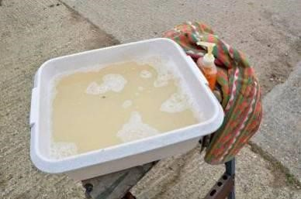

**Fresh Running Water**

Washing facilities should include fresh running water. Providing buckets or troughs of standing water that are shared or reused by several people is not acceptable. They do not allow effective hand washing and reusing water can spread micro- organisms among those using it. Adding a disinfectant to the water does not make the practice acceptable.

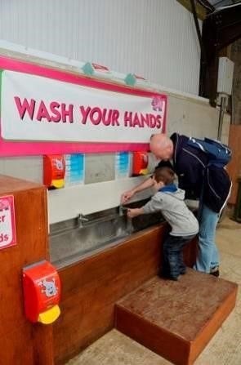

**Left: While site staff have responsibilities, it is also important to encourage parents, teachers and others who have responsibility for visitors to make sure that children and other visitors wash their hands properly.**

**Hot and Cold Water**

In most cases, sites should provide hot and cold running water for the purposes of washing hands. This is normally what will be expected.

Only in exceptional circumstances, such as premises that open on an occasional basis in the summer, it may be acceptable to provide cold running water only, liquid soap preferably via a dispenser and disposable towels. It will be reasonably practicable in most cases for hot and cold water to be provided. Any decision not to provide hot or warm water as part of the welfare provisions should be addressed in the risk assessment.

**Wipes and Gels**

Cleansing wipes or antibacterial gels are not an acceptable substitute for proper hand washing because they may not be effective against some zoonotic diseases. Hand gels should not be provided or be present for the purpose of controlling zoonotic disease.

**Temporary Events**

At temporary events, such as agricultural shows, where suitable permanent washing facilities are provided (e.g. a purpose built toilet and washing block), and are very close to areas where animal contact occurs or may occur, it is acceptable practice for animal exhibitors or others to provide information and signs to indicate that visitors should use these facilities after contact with the animals. If such general visitor washing facilities do not exist or are not situated very close to areas where animal contact occurs or may occur, it will be necessary to provide suitable temporary washing facilities. Washing facilities should be positioned very close to areas where animal contact is allowed or is likely. The Association of Show and Agricultural Organisations (ASAO) may be able to offer further advice to show organisers on controlling risk at agricultural shows. The ASAO can be contacted through their website [http://www.asao.co.uk.](http://www.asao.co.uk/)

### Mobile Petting Attractions

If animals are transported and temporarily shown at different venues (mobile petting attractions), the risks should be controlled to the same standards as any other animal visitor attraction.

The mobile attraction should:

* Risk assess their mobile petting events and ensure that suitable control measures are put in place. Each venue may pose slightly different problems so risk assessments should be site specific.
* Ensure that staff running the mobile events understand their roles and responsibilities.
* Provide information to visitors on the nature of zoonotic risk and control measures in place.
* Use suitable fencing to keep people and animals apart. Single fencing may be fine if there are competent staff supervising visitors in areas where animal contact may occur. Creating a one-way system will allow for greater control over where visitors go.
* Provide supervision for all “animal contact” areas while they are in use.
* Control risks from any “look and see” areas e.g. by double fencing, supervision, signage etc.
* Provide training to staff (whether permanent or temporary) on the nature of zoonotic risk and control measures in place.
* Provide suitable welfare facilities (hot and cold running water, liquid soap, paper towels / hand dryers, bins) and ensure that staff direct visitors to use them following animal contact.
* Keep welfare facilities clean. Welfare facilities should be cleaned at least once each day that they are used.
* Display suitable signage e.g. “animal contact” areas, “non-contact” areas such as eating or play areas, welfare stations, any areas where people must not eat or drink, information signs etc.
* Wherever possible locate any eating or play areas elsewhere on site well away from the animals. If eating or play areas are near to the animals, double fencing should be in place.
* Ensure that visitors are kept out of animal pens and that no eating or drinking takes place in “animal contact” areas or where animal contact is likely.

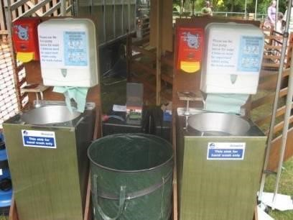

**Left:**

**An example**

**of a hand wash**

**station on mobile**

**petting attraction.**

**Soap, water,**

**paper towels and**

**bins are all**

**provided**

**.**

### Visitor information and signage

Information should be provided to visitors covering the:

* Risks to health.
* Precautions put in place by the site to minimise risks.
* Personal responsibility of visitors to minimise risks, including complying with hygiene precautions and carrying out hand washing.
* Site plan, map, route directions or other information as necessary.

An information sheet aimed at members of the public who visit farms has been published by Public Health England and is available at: [https://assets.publishing.service.gov.uk/government/uploads/system/uploads/attachment_data/file/79](https://assets.publishing.service.gov.uk/government/uploads/system/uploads/attachment_data/file/796824/Farm_visits_avoiding_infection.pdf)

[6824/Farm_visits_avoiding_infection.pdf](https://assets.publishing.service.gov.uk/government/uploads/system/uploads/attachment_data/file/796824/Farm_visits_avoiding_infection.pdf)

Animal visitor attractions may wish to use this leaflet when communicating health and safety messages to visitors.

There are many ways to communicate important health and safety information to visitors, including through the attraction’s website, through site maps and handouts given to visitors, and verbally by staff, on tops and t-shirts worn by staff etc. It is important that the attraction does not rely solely on one method e.g. signage. Using different methods will increase the chances of the messages being heard, understood and followed by visitors.

Information such as leaflets, DVDs, website links or pre-visit packs for schools and other organised groups should be provided to help teachers and others to plan their visit and educate children on safety, prevention of illness and hand washing.

Remember the following:

* Information should include short clear notices at all entrances to the premises to remind visitors of the need for good personal hygiene and to inform them that they should only eat or drink in the designated areas. If notices are too long they will be ignored.
* Consider handouts or stickers for visitors which explain about hand washing.
* Clear, simple signs should be erected in appropriate places reminding visitors to wash their hands when:
* leaving “animal contact” areas,
* before eating,
* before entering and after leaving play areas,
* and when leaving the premises.
* Washing facilities should have signs showing how to wash hands properly.
* Remember that young children may have dummies or toys that they put in their mouths. You should remind accompanying adults not to put dummies that have fallen to the ground back into their children’s mouths.
* Pictograms, audio devices, continuous loop videos or other media may be useful. These will have more effect if placed in strategic locations such as entrances to the attraction where all visitors are more likely to see and hear them, or at entrances to areas where animal contact is likely. It allows short but clear messages to be consistently given to visitors.
* Information should be clearly legible and may be required in languages other than English.

Remember **signs need to be short and snappy** or visitors may not read all the information. Signage must be supplemented by verbal instruction.

**Left: Signage at the entrance to an animal feeding area with a clear message.**

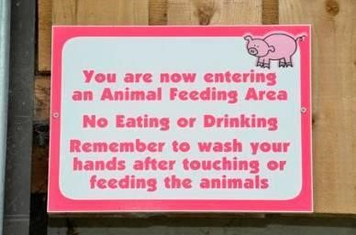

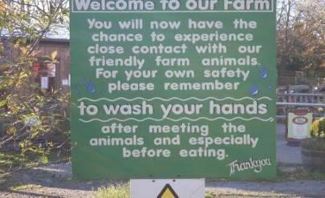

**Right: Signage** **at a farm**

**attraction**

**entrance with** **a clear**  **message.**

**Left: Signage at the entrance to a visitor attraction. Beware that difficult to read text or too much information may put people off properly reading the signs.**

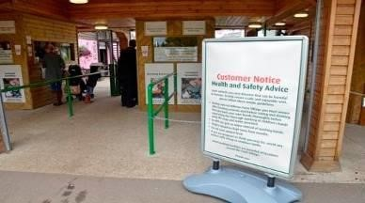

Key health and safety messages must be given to visitors before they are exposed to risk from animal

contact. Introducing videos or short presentations at the start of the visit can give consistent messages in a specified time. This can also ensure that visitors are verbally given key safety messages at least once before they are exposed to risk. The entranceways to attractions can be designed so that visitors are given key information before moving into the site.

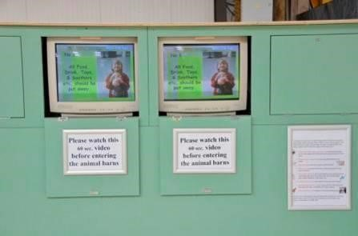

**Left:**

**Give important**

**messages to visitors**

**before they are**

**exposed to risk.**

**Using rolling audio**

**or video can be a**

**good way of doing**

**this.**

### Training of staff and supervision of visitors

You should:

* Ensure staff are trained and instructed about the human health risks associated with animals and the necessary control measures. Don’t forget that training should also be provided for temporary or seasonal staff. Trained staff should understand the control measures in place for your site and as a minimum be able to:
* Identify all “animal contact”, “non-contact” and any “look and see” areas on site.
* Identify all wash station locations on site, or at least the nearest wash station location to where they are working.
* Identify all visitor go and no-go areas. • Identify all areas where hand washing must occur e.g. after visiting “animal contact” areas, before entering eating / play areas etc.
* Explain why hand washing is important.
* Be able to explain the nature of the health risks from animals e.g. zoonoses, causes and possible consequences.
* Explain what the site does to convey the above messages to visitors.
* Ensure staff are trained and instructed on what visitors should or should not do.
* Provide guidance to staff on how to explain the hygiene message to visitors including the importance of thorough hand washing, particularly for children.
* Arrange adequate and appropriate levels of supervision in “animal contact” areas for any time while they are being used. The number of supervisors will depend on the size of the area and the number of visitors permitted or expected in that area at one time.
* Depending on the level of risk and other control measures in place, consider whether supervision is needed as part of your control measures for any “look and see” areas.
* Ensure that children are supervised while they wash their hands. Part of this responsibility rests with parents or teachers, but in some cases, staff may need to help in supervision or remind people to wash hands.
* Remind supervisors in “animal contact” areas to ensure that visitors do not eat, drink or put items in their mouths while in these areas and until they have washed their hands on leaving the contact area.

* Ensure supervisors understand that they should not allow people (especially children) to kiss the animals.
* Stress to your own staff the importance of setting a good example and following good personal hygiene, e.g. thoroughly washing their own hands when necessary, and not eating or drinking in “animal contact” areas.

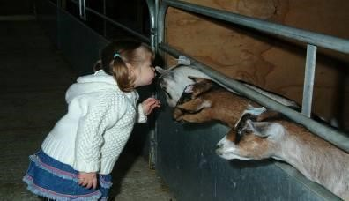

**Left: Staff should**

**not allow people**

**(**

**especially**

**children) to kiss**

**the animals.**

### Livestock Management Procedures

You should:

* Consider producing an animal or farm health plan in consultation with your vet to help reduce the risks from zoonoses.
* Assess whether animals are healthy before moving them to “animal contact” areas or “look and see” areas where visitor contact with animals is possible. Remember that animals carrying STEC or other zoonotic diseases do not necessarily show signs of illness.
* Ensure that animals that have just given birth, or been born, are not put in “animal contact” areas, or “look and see” areas where visitor contact with animals is possible.
* Immediately remove any animals showing signs of ill health or stress from “animal contact” areas or “look and see” areas where visitor contact with animals is possible, until they have recovered. Seek veterinary attention and advice promptly.
* Keep animals and their housing clean. It may be appropriate to put in place a cleaning schedule for animal pens to ensure that it is done regularly.
* Do not use “deep litter” systems.
* Ensure that staff entry to animal housing is properly controlled to ensure that faecal matter is not transferred to areas of the site where visitors will have access; if it is, ensure that the areas are properly cleaned and disinfected before visitors are allowed back into the area.
* Consider whether replacement stock can come from within the premises rather than being brought in (this would reduce the likelihood of new infections being inadvertently brought on to the premises).
* Where possible, source replacement livestock (especially young animals for bottle- feeding) from a reputable supplier with known health status where the stock-keeper will have ensured that they have received an adequate supply of colostrum after being born.
* Try to minimise movement and mixing of animals from different groups. This is particularly important to minimise the shedding of STEC and other zoonotic diseases by ruminants such as cattle, sheep and goats.
* Regularly check all animals on display for evidence of illness, consulting your vet as appropriate.
* Regularly empty and clean water troughs and provide the animals with clean drinking water.

### Manure and compost heaps

You should:

* Position manure or compost heaps well away from areas that visitors can access, or fence them off.
* Prevent or contain any liquid run-off where this might contaminate visitor areas or routes.
* Prevent dried contaminated material (e.g. bedding) being blown onto clean non- contact areas.
* Not allow visitors to collect and bag their own compost or manure.

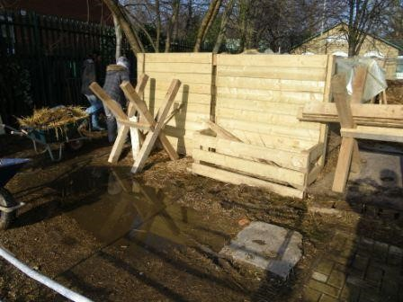

**Left: Keep**

**visitors away**

**from manure**

**and compost**

**heaps.**

# CHAPTER 6: THE ROLE OF INFORMATION IN RISK CONTROL

This chapter considers the role of information and education in risk control. We emphasise the need to give visitors the knowledge to consider their behaviour so they can take some responsibility for their own health and safety. **However, the primary control measure remains in the design and layout of the site being organised in such a way as to prevent or control visitor contact with animals and animal faeces.**

The management of safety should be an integral part of your overall system to meet all the needs of your visitors. There are opportunities at different stages of the process.

Well-designed safety information should:

* Alert visitors to the nature and severity of hazards and risks and provide information about restrictions.
* Give visitors the information to understand risks to which they are likely to be exposed, and the precautions they should adopt.
* Give information about the nature and extent of risk control measures provided by the site operator.
* Make clear to visitors what is expected of them, on the understanding that they share responsibility for their own safety.

Our aim should not be to disclaim responsibility. Signs and leaflets that state visitors ‘enter at their own risk’ have little validity in civil law. However, providing good control measures and safety information that ensures visitors are made aware of hazards should help to prevent accidents and ill health. It may also help to demonstrate that you have acted reasonably in the event of a claim against you if an accident does occur.

Good information can help visitors to develop the skills and confidence to take appropriate responsibility for their own safety.

### Different ways of providing information

* Leaflets, posters, tickets and booklets
* Signs (including pictorial), notices and information boards
* Audio and/or video messages
* Use of signs with themed characters/colour coding along the route
* Verbally
* Messages on staff uniforms such as t-shirts
* Websites
* Recorded telephone information lines

You should identify any partners to your visitor attraction and work with them to achieve a common information strategy.

### Diversity and social inclusion

Think about the needs of different types of visitor. Ensure that any information you publish is accessible for all. Consider different formats, sizes, typefaces, colours and languages.

### The role of education

If your organisation has an education strategy, include visitor safety within the wider educational objectives, particularly when preparing guidance for site visits. Educational opportunities include:

* Direct work with schools and communities.
* Indirect work, for example, via website information
* Work with school and community groups that organise activities in the countryside. Use the opportunity for local staff to explain the guiding principles and emphasise how visitors have some responsibility for their own safety.
* Signage can play an important part in communicating health and safety risks, information and instruction to visitors. However, there should not be a reliance on signage as the only way to communicate vital health and safety information and instruction. Other methods such as verbal communication of the significant risks (contracting zoonotic diseases) and critical control measures (hand washing after touching animals, before eating etc.) should be used where reasonably practicable.

## SIGNAGE

### Advisory, warning and prohibition signs

You may need advisory, warning or prohibition signs to tell visitors about things that have an impact on their visit. However, do not put up signs unless your risk assessment indicates that they are the most appropriate measure for risk control. Where possible, eliminating the hazard is better, for example creating a route that avoids the hazard or double fencing animals to prevent unsupervised contact.

When you decide to use signs you must give thought to their content, design, location and maintenance, if they are to be effective. You should not rely solely on signage to communicate important health and safety information.

**Advantages of signage:**

* Concise means of conveying information.
* Simple pictorial information widely understood.
* Relatively cheap to produce and install.
* Can be used to warn visitors of hazards that are not readily obvious.

**Limitations of signage:**

* Can be missed or ignored by intended audience.
* Limited effectiveness for children.
* Limited value for foreign language speakers.
* Limited value for the visually impaired.
* Visually intrusive in places of beauty or historical significance.

**Some additional considerations on signage:**

* Poorly designed or badly positioned signs are not effective.
* Do not rely solely on signage, use verbal instruction as well.
* Signs can be used together with other physical measures, such as fencing. They can explain why access is restricted.
* Overuse of signs or leaving old signs in place after the hazard has gone undermines their effectiveness.
* The use of signs to disclaim responsibility or liability is not usually appropriate.
* Signs must be regularly inspected and maintained.
* Keep signage short, sharp and clear. Wordy signage boards are less likely to be read by visitors.

### Sign design

When you are certain that a sign is needed, decide which category is appropriate. There are standard designs and colours for each category. These are prescribed by the [Health and Safety (Safety Signs and Signals) Regulations 1996](http://www.legislation.gov.uk/uksi/1996/341/contents/made) . Although these regulations apply to the safety of employees in work situations, there is great merit in applying them, as far as is practicable, to visitor safety signs.

There are many different types of signage. However the following types may be most useful to you in an animal visitor attraction setting:

* First aid signs – giving information on first aid facilities.
* Fire safety signs – information on fire safety precautions.
* Safety signs – signs giving information, for example about the nature of zoonotic risk.
* Prohibition signs – a sign prohibiting a behaviour, for example: no eating or drinking in this area, etc.
* Mandatory signs – a sign prescribing a behaviour, for example: wash your hands before leaving this area, wash your hands after touching animal pens etc.

You can use an information board to give a fuller explanation and incorporate other information about, for example, emergency procedures, management strategy, nature conservation, or environmental protection. However, beware of information overload. Ideally signage should be clear, of suitable size, and quickly and easily understood at a glance.

### Sign location

Give careful consideration to the position of signs. General warning notices need to be seen on arrival by as many visitors as possible. They are usually located at the main points of access to a property. Signs in car parks are best placed at the point where visitors exit on foot to the place of interest.

Warn visitors about hazards in time for them to take in and act on the information before being exposed to the risk. This can be particularly important for controlling children.

Sometimes repeat signs are necessary for hazards that recur along a route.

### Monitoring and review

Observe how people react to signs and notices to ensure that they are in the correct location, understood and acted upon.

Check them regularly for damage and deterioration. Remove signs as soon as they become out of date.

**Communications strategy checklist**

* Who is the audience you want the information to reach?
* Consider specific audiences, e.g. people new to the site or particular age/ability groups.
* Don’t forget even regular visitors need reminders.
* How is the information going to reach the audience?
* Consider information given prior to the visit on a website and at the location through maps, leaflets and signs. Staff wearing t shirts with short key messages e.g. “wash hands after touching animals”, or “wash hands before eating or drinking” may also be an affective form of communication.
* Communicating the same message a variety of ways e.g. signage, verbally, websites, t

shirts etc may be more effective that simply relying on one method.

* Have you met the needs of people with varying levels of skill and ability?
* Can your signs be understood by all visitors or their parent/carer/guardian?

* Have you reached your intended audience?
* This is hard to assess without research or survey work, but you may get some idea from hits on a webpage.
* Feedback forms that visitors can fill out at the end of their visit may also provide a source of information on what works and what doesn’t.
* Has the information been effective?

* Monitor the behaviour of your visitors to see if you have achieved your objectives, this is something that you can ask your staff to do.
* Periodically review your strategy and makes changes / improvements where required.

# CHAPTER 7 – ADVICE TO TEACHERS AND OTHERS WHO ORGANISE VISITS FOR CHILDREN

This advice is for teachers and others who organise farm visits for children. It explains actions that you can take to reduce the risk of ill health arising from contact with animals.

All animals naturally carry a range of micro-organisms, some of which can be transmitted to humans, where they may cause ill health. Some of these, such as *Escherichia coli O157* (*E. coli* O157) or *Cryptosporidium parvum* (a microscopic parasite), present a serious health hazard and have the potential to cause serious illness and health problems which may be particularly severe in young children, the elderly, or those with reduced immune systems.

As with many other educational or recreational activities, visits can never be considered free from all risk. However, while the hazards are real, the risk of infection can be readily controlled by simple everyday measures. The following practical steps will help make your visit even more safe, healthy and enjoyable.

**Before your visit, you should:**

* Read this Industry Code of Practice so that you understand what control measures the farm should have in place. You can then discuss arrangements for your visit with the management at the site.
* Confirm that the control measures provided at the site match the recommendations in the Industry Code of Practice.
* Seek advice from your local authority or organisation on what the appropriate ratio of pupils to teachers/leaders/assistants/parents should be.
* Discuss and agree with the supervisors, parents or staff of the school, crèche leaders of youth organisations etc. their roles and responsibilities during the visit. In particular, they must understand the need to make sure that the children wash, or are helped to wash, their hands thoroughly in the following four situations: after contacting animals, before eating, before and after using play equipment, and when leaving site.
* Before your visit cover at least the following key points with the children:
  + Explain the rules for the visit, including stressing that they must not eat, drink or chew anything (including sweets) outside the areas in which you permit them to do so.
  + Explain why they must wash their hands thoroughly after contact with the animals, before eating or drinking anything etc.
  + Demonstrate how to wash their hands properly.
  + Discuss the requirements for appropriate clothing, including suitable footwear. You should liaise with the attraction to ascertain what this is.
  + Checking that cuts, grazes etc on children’s hands are covered with a waterproof dressing.

**During the visit make sure that the children:**

* Are reminded of the rules while on site.
* Do not kiss animals.
* Always wash their hands thoroughly before eating, after any contact with animals, before and after using any play equipment at the site, and again before leaving the site.
* Eat only food that they have brought with them or food for human consumption that they have bought on the premises, in designated areas.
* Never eat food that has fallen to the ground.
* Never taste animal foods.
* Do not suck fingers or put hands, pens, pencils or crayons etc. in mouths.
* Where possible, clean or clean and change their footwear before leaving. The site should have facilities to clean footwear as you leave the site.
* Wash their hands after cleaning / changing their footwear.

**Check that the children stay in their allocated groups during the visit, and that they:**

* Do not use or pick up tools (e.g. spades and forks) or touch other work equipment unless permitted to do so by site staff.
* Do not climb on to walls, fences, gates or animal pens etc.
* Listen carefully and follow the instructions and information given by the site staff.
* Approach and handle animals quietly and gently.
* Do not chase, frighten or torment the animals.
* Do not wander off into unsupervised or prohibited areas e.g. manure heaps.
* Know what to do if they get separated from the group for any reason.

**Remember the children are your responsibility during the visit:**

* You should supervise them during the visit, especially during hand washing to make sure that each child washes thoroughly. Site staff may be able to help with this supervision.
* Allow plenty of time for hand washing before eating or leaving the site so that the children do not have to rush.

### What to do if you or any of your party become ill after a visit

* If a member of your group shows signs of illness (e.g. sickness or diarrhoea) after a visit, advise them or their parent/guardian to visit the doctor and explain that they have had recent contact with animals.
* Please also contact the attraction you visited and inform them of the illness.

# CHAPTER 8: INCIDENT REPORTING AND INVESTIGATION

Incident reporting is an important element in managing visitor safety. We want our visitors to enjoy their experience and return home unharmed. It is essential to learn from incidents and near misses that do occur.

**Why investigate incidents?**

* To help manage the incident.
* To prevent future similar incidents.
* To check whether your risk control measures are sufficient and effective.
* It may be a statutory requirement. Some cases of ill health must be reported, usually to the environmental health department of your local authority, or to the Health and Safety Executive.
* To provide information in case there is a claim for compensation, or a need to defend a legal action.
* To identify trends in the pattern of incidents or accidents.
* To measure whether your safety record is improving or worsening.

### Common obstacles to investigations

* Difficulty in collecting information.
* Fear of blame. To counteract this it helps to create a management culture in which staff and visitors are encouraged to report accidents and near misses.
* Over-complicated reporting systems. Introduce simple and clear systems that minimise paperwork.
* Staff being unaware of the value of the information they supply. It is essential to give feedback and show how things have changed as a result of incident investigations.
* Visitors may not know how or where to report incidents.

### Incident reporting procedures

It is important to have a clear process for reporting and investigating incidents. This should include consideration of the need to inform insurers or involve legal advisors if claims are likely to result. You should also consider whether the incident could give rise to media enquiries and how these would be handled.

You are legally bound under the Reporting of Injuries Diseases and Dangerous Occurrences Regulations 2013 (RIDDOR) to report certain accidents, dangerous occurrences and types of ill health to the enforcing authority.

You must also ensure that the person who investigates an incident has the necessary skills, knowledge and experience.

Many organisations have specific forms to report incidents and record investigations. Often the two are combined. They typically gather the following information:

### Basic facts

* Where the incident happened
* What happened
* Date and time
* Who was involved
* Physical site characteristics
* Facilities or equipment involved
* Activities of those involved
* The weather at time of incident (you may also wish to consider details of clothing and footwear worn at the time)
* The nature of actual or potential exposure to possible infection • Damage to property or environment (actual or potential) • What control measures, if any, were in place.

### Gathering evidence

Evidence is critical to establish the facts and determine the causes of incidents and it should be gathered before any changes are made to the site (other than those necessary to prevent any recurrence), and whilst the events are fresh in people’s minds. Information to be gathered should include:

* Photographs, video recordings or CCTV of the incident/site.
* Witness statements written or recorded.
* Any equipment or infrastructure damaged or otherwise, implicated in the incident.

Be careful when asking for statements at the time of the event from witnesses who may be distressed. It might be more sensitive to ask for an address and telephone number in order to make contact later.

### Incident history

The investigator needs to establish whether:

* A similar incident has happened before.
* Recommendations had previously been made to prevent a recurrence.
* If so, were the recommendations carried out?

### Causes

As well as looking at any obvious direct causes of the incident, it is necessary to look beyond the immediate cause of an incident to see if there are important underlying reasons. Often there are several inter-related causes.

### Recommendations

Recommendations are actions to lessen the possibility of a similar incident occurring in the future or to mitigate its effect to an acceptable level. Where recommendations are made they should be given a timescale for implementation and responsibility should be allocated for carrying it out.

### Review

There should be a review to see if the recommended actions have been taken and to assess whether they were adequate and appropriate. Responsibility for carrying out the review should be allocated to a person with an appropriate level of authority.

# CHAPTER 9: DEALING WITH A MAJOR INCIDENT

A number of zoonotic diseases are notifiable under veterinary and/or human health legislation. However, not all zoonotic diseases in animals or humans are notifiable.

The primary purpose of the notification system is to identify possible outbreaks and epidemics and initiate appropriate action as soon as possible. Accuracy of diagnosis is secondary, and generally *clinical suspicion* is all that is required. If the diagnosis later proves incorrect, the notification can be changed or cancelled.

An Incident or Outbreak Control Team (OCT) will be formed for significant outbreaks of zoonotic disease. The relevant public health authority responsible for managing incidents/outbreaks would apply its standard procedures in managing the event. Contact Public Health England, Public Health Wales and Health Protection Scotland for more information.

Depending on the individual situation and disease, membership of the OCT may include representatives from:

* Public Health England, Public Health Wales or Health Protection Scotland.
* The local Health Protection Unit and the Consultant etc.
* Primary Care Trust.
* Local acute trust (Microbiologist or Virologist, Infection Control Nurse).
* Other agencies as necessary may also be included, for example, the Health & Safety Executive, Environmental Health, or the Food Standards Agency.
* Veterinary involvement may be provided by the Animal and Plant Health Agency.

Further PHE guidance regarding the investigation of zoonotic disease can be found at <https://www.gov.uk/government/publications/zoonotic-diseases-investigation-guidelines>

Government information on a number of infectious diseases including zoonotic diseases can be found at <https://www.gov.uk/topic/health-protection/infectious-diseases>

# CHAPTER 10: THE LAW AND VISITOR SAFETY

This chapter looks at the legislation and court judgements that affect visitor safety and outlines your responsibilities under the law. Some of the references in this chapter to public health legislation are specific to England or Wales. There may be differences in Scottish legislation.

Someone injured through your negligence can bring an action for damages against you in a civil court of law. If you are found negligent, you may be ordered to pay compensation for loss of earnings, medical expenses, pain, suffering and the like.

Claims for damages after accidents are perceived to be on the increase, with solicitors and accident claim practitioners touting for new business by offering ‘no win no fee’ terms. Concern about the growth of the ‘compensation culture’ led to the introduction of the Compensation Act in 2006. This brought in changes to the law on liability and breach of statutory duty aimed at tackling perceptions that can lead to a disproportionate fear of litigation and risk-averse behaviour. Despite this, Lord Young states in his 2010 report ‘Common Sense, Common Safety’, the problem of the compensation culture prevalent in society today is one of perception rather than reality. The number of claims for damages due to an accident or disease has increased slowly but nevertheless significantly over recent years. Furthermore, there is clear evidence that the public believes that the number of claims and the amount paid out in damages have also risen significantly.

Not only organisations but also individuals can face prosecution in a criminal court for not complying with legal duties imposed by government legislation. You can be fined, or even face imprisonment if found guilty in a criminal court.

**Criminal law**

## Health and Safety Legislation

### Health and Safety at Work etc. Act 1974

A criminal offence will arise from a failure to comply with legal duties imposed by the Health and Safety at Work etc. Act 1974 (HSWA) and regulations made under it.

This legislation places a duty on employers to ensure, as far as is reasonably practicable, that in the course of conducting their undertaking, members of the public are not put at risk.

The phrase ‘conducting their undertaking’ also includes cleaning, maintenance and repair of the plant, machinery and buildings necessary for carrying on the business. The employer cannot delegate responsibility for this duty. Therefore, in effect, you need to consider the consequences of the actions of contractors as well as your employees.

You need to consider the cost and effectiveness of any precautions that you can take to minimise risk of harm. If a precaution is cheap, easy to take and is very effective, then it is reasonable to implement it even if the risk of harm is small. If the risk of harm is great, then more expensive precautions may be reasonable. These decisions need to be balanced against the benefits arising from the site or the activity, as we have considered in earlier chapters.

### Control of Substances Hazardous to Health Regulations 2002 (as amended) (COSHH)

*E. coli* O157 and other micro-organisms that may cause ill health are subject to the Control of Substances Hazardous to Health (COSHH) Regulations 2002 (as amended). These Regulations require an employer or self-employed person to:

* Assess the risks to employees, self-employed people and the public from exposure to hazardous substances, including micro-organisms.
* Prevent, or, where this is not reasonably practicable, adequately control exposure to the hazardous substances.
* Introduce and maintain control measures.
* Inform, instruct and train employees about the risks and precautions to be taken.
* Inform visitors about the risks and precautions to be taken.
* Regularly review the assessment and the effectiveness of control measures.

Guidance on COSHH can be obtained from the HSE website <https://www.hse.gov.uk/coshh/index.htm>

### Management of Health and Safety at Work Regulations 1999 (as amended)

The Management of Health and Safety at Work Regulations 1999 require you to carry out risk assessments to identify hazards and take any necessary steps to reduce the risk of an incident.

Regulation 3(1)(b) states: ‘Every employer shall make a suitable and sufficient assessment of the risks to the health and safety of persons not in his employment arising out of or in connection with the conduct by him of his undertaking.’

In effect this means that your risk assessments should consider the risks to visitors you invite onto your property, or other people who might be affected by your undertaking or your activities. Risk assessment is discussed in Chapter 4.

Regulation 5 states: ‘Every employer shall make and give effect to such arrangements as are appropriate, having regard to the nature of his activities and the size of his undertaking, for the effective planning, organisation, control, monitoring and review of his preventive and protective measures.’

This refers to the systems and arrangements that you should set up to ensure that health and safety is effectively managed, controlled and reviewed. Where the employer employs five or more employees, the arrangements should be recorded. We discuss how you can meet these requirements in Chapter 3.

### Reporting of Injuries, Diseases and Dangerous Occurrences Regulations 2013 (RIDDOR)

You are legally bound under RIDDOR 2013 to report certain accidents, dangerous occurrences and types of ill health to the enforcing authority. The enforcing authority will either be the local authority or the Health and Safety Executive. They may well send an inspector to investigate. The authority will also investigate complaints made by members of the public. It is essential that you can demonstrate that you have effective procedures in place to identify and manage risk.

### Enforcement of health and safety legislation

Responsibility for the enforcement of the above health and safety legislation rests with the Health and Safety Executive (HSE) and local authorities. Their inspectors have powers to investigate incidents and complaints or carry out routine inspections. When there has been a breach of health and safety law the enforcing authority can serve improvement or prohibition notices or prosecute.

The local authority will be the enforcing authority for most visitor attractions. However, where the attraction is a working farm, the enforcing authority will be the Health and Safety Executive.

Where an offence is committed with the ‘consent, connivance or neglect of any director, manager, secretary or other similar officer’, that person may be guilty of an offence along with the organisation. If the breach in the law results in death, the police are involved and they may refer the case to the Crown Prosecution Service.

### Independent Regulatory Challenge Panel

An Independent Regulatory Challenge Panel has been established to handle complaints about advice given by either the HSE or local authority inspectors and will seek the expert advice of assessors in reaching a conclusion.

Any case where someone believes the enforcing authority is incorrect or has gone beyond what is required to control the risk adequately is eligible for consideration by the panel. The panel will not consider issues where other independent appeals processes exist, such as enforcement notices or prosecutions.

Further information is available at: <https://www.hse.gov.uk/contact/challenge-panel.htm>

**The Corporate Manslaughter and Corporate Homicide Act 2007** created a criminal offence of corporate manslaughter in England, Wales and Northern Ireland and corporate culpable homicide in Scotland. This Act applies to all companies, most government bodies, partnerships, trade unions, employers’ associations and incorporated charities. Crown immunity has been largely abolished. The Act does not apply to unincorporated bodies such as some charities, friendly societies etc. or individuals.

Corporate manslaughter and corporate homicide investigations are led by the police. They can be lengthy and intrusive. The existing provisions of the Health and Safety at Work etc. Act 1974 and the regulations made under it would still apply.

**Public Health Legislation**

#### Application of the Health Protection Regulations 2010 (England & Wales)

These health protection powers are for use where voluntary cooperation to avert a health risk cannot be secured and where other methods of control are ineffective, unsuitable or disproportionate to the risk involved. The Department of Health and Social Care has published guidance from Public Health England and the Chartered Institute of Environmental Health, which describes how these powers should be used.

Powers that impose restrictions or requirements are conditional on strict criteria being met. The local authority makes an application to a justice of the peace (JP) who must be satisfied that the relevantcriteria are met. The criteria cover evidence of infection or contamination, assessment of the potential for significant harm to human health, risk of spread to others and necessity for action to be taken in order to reduce or remove that risk. The legislation also contains varioussafeguards for people who might be subject to the legal measures.

The measures are contained in the Public Health (Control of Disease) Act 1984 (as amended) together with the Health Protection (Local Authority Powers) Regulations 2010 and the Health Protection (Part 2A Orders) Regulations 2010.

Information about public health legislation in Scotland is available at:

<http://www.legislation.gov.uk/asp/2008/5/contents>

**Civil law**

The foundation of most personal injury actions is in proving negligence under common law. An action for damages is brought in the civil courts.

To win an action and be awarded compensation the injured person must be able to demonstrate that they were owed a duty of care, and there was a breach of that duty leading to the injury.

A civil case can also be brought for breach of statutory duty that results in injury or ill health.

Common law duties essentially derive from decisions made by judges over the years. Under common law you owe someone a duty of care if there is:

* sufficient proximity between you and the person injured, and it was
* reasonable to foresee that harm may result from your actions, and
* it is fair, just and reasonable to impose a duty of care on you.

Proximity can be geographical, contractual, or through a care situation (for example between teacher and child). If you breach that duty of care, and foreseeable physical or psychological damage results, then you are liable to negligence. An employer may be held liable for the negligence of his employees (this is called vicarious liability).

The visitor must take reasonable care for his own safety. If he doesn’t and comes to harm, then his

‘contributory negligence’ would lessen any claim against you.

Note that children cannot be expected to appreciate dangers in the same way as adults. It is highly unlikely that contributory negligence could be attributed to the actions of a very young child. Adults, however, will be expected to exercise responsibility for children in their care.

In civil law, the duty of care has been further defined by legislation. Under the Occupiers’ Liability Acts of 1957 (OLA57) and 1984 (OLA84), the occupier of premises owes a duty of care to lawful visitors (OLA57) and trespassers (OLA84), by reason of the state of the premises and things done or omitted to be done on them. In Scotland, a similar duty of care is owed under the Occupiers’ Liability (Scotland) Act 1960.

The ‘occupier’ is the person or body that has sufficient control over the premises to be in a position to take the steps necessary to protect people who otherwise may be at risk.

If there is more than one occupier, each owes a duty of care that is in relation to the degree of control each has over the premises.

An occupier has the duty of care and cannot delegate this duty to someone else. So, in effect, you may be responsible for the actions of contractors working on your behalf.

#### Visitors

Under Section 2(2) of the OLA57, the occupier has:

‘A duty to take such care as in all the circumstances of the case is reasonable to see that the visitor will be reasonably safe in using the premises for the purposes for which he is invited or permitted by the occupier to be there.’

You must consider the particular needs of people you invite onto your property.

You must be able to demonstrate that your precautions are reasonable in the circumstances.

You must be prepared for children to be less careful than adults. Furthermore, a warning sign, however clear in itself, cannot warn if the child is unable to read. However, in some circumstances, particularly in the case of a young child, the parent may hold the primary duty of care.

Warning a visitor of dangers might be sufficient to absolve you from liability, but only if it was sufficient to enable the visitor to be reasonably safe.

Under OLA57, you can choose to restrict or exclude your liability by imposing entry conditions. However, the Unfair Contract Terms Act 1977 says that:

‘A person cannot by reference to any contract term or to a notice exclude or restrict his liability for death or personal injury resulting from negligence.’

In the case of other loss or damage, liability can only be excluded or restricted if the terms are reasonable.

# APPENDIX 1: CHECKLIST

The following checklist can be used to help you to address issues and keep your customers safe from exposure to microbiological contaminants and zoonoses. This document may help you record your COSHH assessment. Remember that you will need to ensure that your COSHH assessment is specific to your site.

|  |  |  |  |  |  |
| --- | --- | --- | --- | --- | --- |
| **TOPIC** | **WHAT IS IN PLACE?** | **WHAT FURTHER**  **ACTION IS**  **REQUIRED?** | **BY**  **WHO?** | **BY**  **WHAT**  **DATE?** | **ACTION**  **SIGNED AS**  **COMPLETED** |
| **Risk Assessment** |  |  |  |  |  |
| Has a site specific risk assessment been completed which identifies and addresses the significant risks on site?    If you have 5 or more employees the risk assessment should be recorded. |  |  |  |  |  |
| **Policy** |  |  |  |  |  |
| Is there a policy which sets out the approach to maintaining visitor safety?    If you have 5 or more employees the policy should be written down.    A policy usually comprises of 3 main areas:   1. A statement of general policy on health and safety which sets out your commitment to managing health and safety, and what you want to achieve. 2. A responsibility section which details the roles and responsibilities of your staff with regards to specific health and safety actions. 3. An arrangements section which sets out the detail of what you are going to do in practice to achieve the aims set out in your statement of general policy. |  |  |  |  |  |

|  |  |  |  |  |  |
| --- | --- | --- | --- | --- | --- |
| **Visitor Information** | | | | | |
| Are visitors provided with adequate information on:   1. The health and safety risks on site e.g. risks from zoonotic disease etc 2. The control measures in place e.g. double fencing, washing facilities, designated eating areas, signage etc   before they are exposed to those risks and control measures?    Information can be provided to visitors in a number of ways. The attraction’s website, audio and video, site maps, staff t shirts, handouts, signage and verbal explanation may all have a part to play. Attractions should not rely on one method (e.g. signage) to convey crucial health and safety information to visitors.    Leaflets or pre-visit packs should be provided to schools and other organised groups to aid planning. |  |  |  |  |  |
| **Premises Layout and Routes** | | | | | |
| Prevent visitor access to high risk areas.    Are the public access areas segregated from the main higher risk work areas and moving vehicles?    Any areas to which members of the public do have access should have risks properly controlled. |  |  |  |  |  |
| Are the visitor routes around and through the attraction clearly defined?    Clearly defined routes allow for better control over visitor movements. Routes may be defined by a mixture of pathways, signage, fencing and supervision. |  |  |  |  |  |
| Are the visitor routes kept reasonably clean and free from |  |  |  |  |  |

|  |  |  |  |  |  |
| --- | --- | --- | --- | --- | --- |
| build-up of animal faeces?    Sensible hygiene practices indicate that visitor routes should be clean to minimise risks of contamination of hands and footwear and reduce transfer of faecal matter to other areas of the attraction such as eating or play areas.    A system to monitor walkways for signs of faecal  contamination, and then where necessary clean them should be in place. |  |  |  |  |  |
| Are washing stations clearly signposted on the route around premises? |  |  |  |  |  |
| Are the different areas of the attraction clearly defined? These include:     * “Animal contact” areas (areas where animal contact is allowed or encouraged e.g. petting or feeding areas). * “Look and see” areas (areas where animal contact may not be intended but is still possible) e.g.   paddocks, pens or fields where animals are kept. The risks from such areas still need to be controlled.  Many attractions may opt make these areas into “non-contact” areas by double fencing and so preventing animal contact.   * “Non-contact” areas (areas where animal contact must be prevented e.g. eating or play areas). |  |  |  |  |  |
| Are visitors advised to wash their hands before leaving the site?    Information should be provided to visitors reminding them to wash their hands before leaving site.    Signage placed at the exit points to the site may be one way to remind visitors of this message. |  |  |  |  |  |

|  |  |  |  |  |  |
| --- | --- | --- | --- | --- | --- |
| Visitors should also be reminded to wash their hands if they have changed footwear, cleaned wheelchairs or buggies before leaving site. |  |  |  |  |  |
| **“Animal Contact” Areas** | | | | | |
| Are adequate washing facilities provided adjacent to areas of animal contact?    If washing facilities are not conveniently located there is less chance that they will be used.    It is important that washing facilities are located adjacent or very near to high risk areas such as “animal contact” areas. |  |  |  |  |  |
| Are visitors prevented from entering animal living pens?    You need to prevent the visitors entering animal living pens, as faeces or contaminated bedding will be underfoot.    Separate designated clean animal petting areas should be used when supervised contact with animals is allowed to take place.    Are separate, clean, supervised petting areas provided? |  |  |  |  |  |
| Are visitors prohibited from eating, drinking and smoking in the “animal contact” areas?    Eating drinking and smoking in “animal contact” areas should be prevented. This can be achieved by a combination of adequate supervision, signage, and where necessary challenging visitors who do not adhere to these site rules. |  |  |  |  |  |
| Is contaminated bedding or run-off prevented from contaminating walkways or other visitor areas?    Pens with solid lower level boarding can reduce the spread |  |  |  |  |  |

|  |  |  |  |  |  |
| --- | --- | --- | --- | --- | --- |
| of faecal matter to pathways and other visitor areas. |  |  |  |  |  |
| Are animals deemed unsuitable for contact with visitors (e.g. sick, ill or aggressive animals) properly segregated so that they cannot come into contact with visitors? |  |  |  |  |  |
| Is there adequate supervision of “animal contact” areas at all times while they are used by visitors?    Visitor contact with animals should be supervised by site staff. Staff should understand the required control measures before during and after visitor contact with animals. |  |  |  |  |  |
| Are suitable hand washing facilities located so that they can be used immediately after visitors leave “animal contact” areas?    Visitors should be able to wash and dry their hands using hot and cold or warm water, liquid soap and paper towels / hand dryers immediately after contact with animals.    If washing facilities are not conveniently located next to “animal contact” areas they may not be used by visitors after leaving “animal contact” areas. |  |  |  |  |  |
| Are visitors reminded to wash their hands when leaving “animal contact” areas?    Visitors can be reminded to wash their hands after animal contact / when leaving “animal contact” areas by displaying highly visible signage placed in prominent locations at the exit points to “animal contact” areas, and by verbal reminders from supervisors in the “animal contact” areas. Reliance should not be placed solely in signage to convey this important message. |  |  |  |  |  |
| Pen divisions and gates in “animal contact” areas should be regularly cleaned in order to reduce the risk of spreading |  |  |  |  |  |

|  |  |  |  |  |  |
| --- | --- | --- | --- | --- | --- |
| micro-organisms.    A cleaning schedule should be put in place to ensure that pen divisions and gates in “animal contact” areas are cleaned periodically. The frequency of cleaning should be determined by risk assessment but influencing factors will include the number of people visiting the “animal contact” areas.    Putting in place a system to record when cleaning takes place is a useful aid to monitor that cleaning is taking place according to schedule. |  |  |  |  |  |
| **“Look and See” Areas** | | | | | |
| Have all “Look and See” areas around the attraction been identified and action taken to assess and control risk?    It is considered reasonably practicable in many cases for these areas to be double fenced. This is the best form of control measure as it prevents visitor contact with animals or potentially contaminated fencing but will not impact on visitor experience. |  |  |  |  |  |
| **Eating Areas** | | | | | |
| Are visitors in eating areas prevented from making contact with animals in adjacent areas?    This can be achieved by provision of double fencing.    Remember to consider the location of temporary eating areas such as ice cream vans and sweet kiosks.    Eating in areas where contact with animals is possible should not be permitted. |  |  |  |  |  |
| Are suitable hand washing facilities located so that they can be used before visitors enter eating areas? |  |  |  |  |  |

|  |  |  |  |  |  |
| --- | --- | --- | --- | --- | --- |
| Visitors should be able to wash and dry their hands using hot and cold or warm water, liquid soap and paper towels / hand dryers before using eating areas.    If washing facilities are not conveniently located near to eating areas they may not be used by visitors. |  |  |  |  |  |
| Are visitors advised to wash their hands before eating or drinking?    Information should be provided to visitors reminding them to wash their hands before eating, drinking or smoking.    Signage placed around the site and especially at entrances to eating areas may be one way to remind visitors of this message. |  |  |  |  |  |
| **Play Areas** | | | | | |
| Are visitors in eating areas prevented from making contact with animals in adjacent areas?    This can be achieved by provision of double fencing.    Are children prevented from reaching and touching animals in areas adjacent to play areas?    Where play areas are adjacent to animal areas, animal contact should be prevented, e.g. by double fencing. |  |  |  |  |  |
| Are suitable hand washing facilities located so that they can be used before and after visitors use play areas?    Visitors should be able to wash and dry their hands using hot and cold or warm water, liquid soap and paper towels / hand dryers before and after using play areas.    If washing facilities are not conveniently located near to play |  |  |  |  |  |

|  |  |  |  |  |  |
| --- | --- | --- | --- | --- | --- |
| areas they may not be used by visitors. |  |  |  |  |  |
| Are visitors advised to wash their hands before and after using play areas?    Information should be provided to visitors reminding them to wash their hands before and after using play areas.    Signage placed around the site and especially at entrances to play areas may be one way to remind visitors of this message. |  |  |  |  |  |
| Play equipment should be regularly cleaned in order to reduce the risk of spreading micro-organisms.    A cleaning schedule should be put in place to ensure that play equipment is cleaned periodically. The frequency of cleaning should be determined by risk assessment but influencing factors will include how often the equipment is used and by how many people.    Putting in place a system to record when cleaning takes place is a useful aid to monitor that cleaning is taking place according to schedule. |  |  |  |  |  |
| **Washing Facilities** | | | | | |
| Washing facilities should comprise of the following:   * Hot and cold, or warm, running water * Dispensable liquid soap (bars of soap are not suitable as they can become contaminated and may increase the micro-biological risk) * Paper towels, pull down material towels or hand dryers     Any deviation from provision of hot and cold or warm water (i.e. provision of only cold water) should be on a risk assessment basis and then only for attractions that open on an occasional basis in the summer. |  |  |  |  |  |

|  |  |  |  |  |  |
| --- | --- | --- | --- | --- | --- |
| Re-usable hand towels are not acceptable.    Liquid soap and safe means of drying hands should always be provided at every washing station.    It is not acceptable to provide bowls of water for visitors to wash their hands. Using bowls of water rather than running water increases the risk of passing on contaminants. |  |  |  |  |  |
| Have a sufficient number of washing facilities been provided?    Are they provided in the right locations, adjacent to the areas where they are required i.e. “animal contact” areas, play areas, eating areas, exit to the premises? |  |  |  |  |  |
| Anti-bacterial wipes or gels are not a suitable substitute for hand washing. They do not provide the same level of protection against zoonotic infection.    Wipes and gels should never be provided as a substitute for handwashing facilities. This is unacceptable.    Ideally wipes and gels should not be provided at all. They should certainly not be provided in locations away from washing facilities. To do so risks visitors using wipes or gels as an alternative to hand washing. |  |  |  |  |  |
| Are all wash stations clearly signposted?    Wash stations should be located near to areas where the risk of infection is higher or where the need to wash hands is greater (e.g. “animal contact” areas, eating areas). As such they should be clearly visible and signage marking that they are wash facilities for visitor use should be provided and prominently placed.    Where wash facilities are not immediately visible when leaving an area of risk e.g. “animal contact” area, highly |  |  |  |  |  |

|  |  |  |  |  |  |
| --- | --- | --- | --- | --- | --- |
| visual signage should be prominently placed to direct visitors to the clearly labelled nearby washing facilities. |  |  |  |  |  |
| Is the water used in hand washing allowed to drain away quickly?    Re-using used hand washing water must not be possible.    Bowls of water should not be provided for handwashing as this does not adequately control the risk of contamination. Running water should be used when hand washing. |  |  |  |  |  |
| Are there signs displayed at all hand washing stations to instruct on hand washing techniques?    Poor hand washing techniques may not remove  contamination from hands. Signage displayed at all washing stations showing how to properly wash hands can help to reduce the risk by ensuring that visitors understand how to properly wash hands. |  |  |  |  |  |
| Are washing facilities cleaned at suitable intervals depending on use, and at least on a daily basis?    Failure to properly clean washing facilities can lead to spread of micro-organisms that cause disease. |  |  |  |  |  |
| Where required to dispose of paper towels etc, are open or pedal top bins provided in or next to washing areas?    Open top or pedal operated bins eliminate the need to touch the lids of bins and so reduce the risk of hand contamination after washing. |  |  |  |  |  |
| Are there facilities in place to clean wheelchairs, pushchairs or footwear as necessary?    Ideally such facilities should be located close to the exit from |  |  |  |  |  |

|  |  |  |  |  |  |
| --- | --- | --- | --- | --- | --- |
| the attraction so that visitors can use the facilities before they leave the premises.    Visitors should also be able to wash hands after changing footwear etc. |  |  |  |  |  |
| **Staff Training** | | | | | |
| Have staff (including any temporary staff) working at the attraction had sufficient training in order to carry out their role?    Staff should understand basic health and safety information regarding their role such as:   1. Which areas on site are “animal contact” areas, “look and see” areas and which are “non-contact” areas 2. The location of visitor wash stations on site 3. Areas where visitors are and are not allowed to go 4. Areas where hand washing must occur e.g. after animal contact, before using eating areas etc 5. The reasons why hand washing is important 6. Understanding the nature of the health risks from animals e.g. zoonoses, and how infection is passed to humans 7. Explain how the above safety critical information is given to visitors who use the attraction     Staff should have been trained in the 7 areas above and on any specific responsibilities that they have at the attraction. |  |  |  |  |  |
| Are staff (including temporary staff) able to explain how to manage difficult and uncooperative visitors?    Most visitors at attractions will be well behaved. However difficult or uncooperative visitors may endanger themselves or other visitors e.g. repeatedly ignoring requests to wash hands after being in “animal contact” areas or before eating etc may spread contamination and put themselves or other persons at risk. |  |  |  |  |  |

|  |  |  |  |  |  |
| --- | --- | --- | --- | --- | --- |
| The attraction should instruct its staff on what they should do if they encounter difficult or uncooperative visitors. |  |  |  |  |  |
| **Supervision of Visitors** | | | | | |
| Are there sufficient levels of supervision in key areas of the attraction e.g. “animal contact” areas, in order to ensure that visitors adhere to site rules?    Trained supervision for higher risk areas such as “animal contact” areas is an important part of ensuring that risk is controlled.    You should consider whether supervision may also be needed at washing stations. |  |  |  |  |  |
| **Livestock Management** | | | | | |
| Are there procedures for managing the animals and animal housing at the attraction?    Poor management of livestock can increase the risk of visitors being exposed to micro-organisms that can cause disease.    Procedures should be in place which consider issues such as:   * Managing bedding in animal housing to prevent build-up of faecal material * Cleanliness of the animals * How bedding in animal housing should be changed to avoid spreading contamination around the site * How sick/pregnant/stressed animals are managed to minimise risk of any infection being spread to visitors * Checking the animals for signs of illness / stress etc * Proactive and reactive veterinary input into the management of animals |  |  |  |  |  |
| Are animals reasonably clean and are their pens without a build-up of faecal material?    Cross contamination risks increase where animals are dirty. |  |  |  |  |  |
| **Manure and Compost Heaps** | | | | | |
| Are manure and compost heaps and their liquid run-off managed and segregated? Is the spread of faecal matter prevented?    Where possible locate manure and compost heaps away from pedestrian routes. Wherever they are located, visitor access should be prevented, and liquid run off to areas where pedestrians use should be prevented. |  |  |  |  |  |

# APPENDIX 2: SOURCES OF INFORMATION

There are a number of organisations that offer advice and guidance, some of which is freely available and some which is only available to members.

The National Farm Attraction Network [http://www.farmattractions.net](http://www.farmattractions.net/)

Farms for Schools <http://www.farmsforschools.org.uk/>

The National Farmers Union <https://www.nfuonline.com/>

The National Farmers Union Cymru <https://www.nfu-cymru.org.uk/>

The National Farmers Union Scotland <https://www.nfus.org.uk/>

The Association of Show and Agriculture Organisations <https://www.asao.co.uk/>

LEAF Education <https://leafuk.org/education/leaf-education>

Linking Environment and Farming<https://leafuk.org/>

Social Farms and Gardens <https://www.farmgarden.org.uk/>

HSE Agriculture Health & Safety <http://www.hse.gov.uk/agriculture/index.htm>

64